Big picture on front page

Table of Contents

1. Introduction 4

2. Preparations 5

2.1 Build Options 5

2.1.1 Screen Options 5

2.1.2 Audio Option 5

2.1.3 Button Option 5

2.2 Items Included in the Kit 7

2.3 Additional Items Needed 8

2.3.1 Items needed: 8

2.4 Necessary Tools 9

3. Build Steps 10

3.1 Software Installation (SD card prep) 10

3.2 Raspberry Pi Prep 11

3.3 Preparing components 13

3.3.1 Volume Slider 13

3.3.2 USB Port 15

3.4 Case Modifications 16

3.4.1 Front shell 16

3.4.2 Back shell 18

3.4.3 Screen shell 22

3.5 Preparing the AIO board 23

3.5.1 Separating PCB pieces 23

3.5.2 Trim extra PCB pieces 25

3.6 Micro USB power port 28

Figure 1 - Necessary tools 9

Figure 2 - Remove corner of the Pi 10

Figure 3 - Trim Pi USB pad 10

Figure 4 - Pi Kapton tape and solder blobs 11

Figure 5 - Bend volume slider pins 12

Figure 6 - Volume slider plastic before trimming 13

Figure 7 - Volume slider plastic after trimming 13

Figure 8 - Volume slider pieces glued 14

Figure 9 - Trim USB port metal 14

Figure 10 - Front shell, trim interfering plastic 15

Figure 11 - Front shell, open ribbon cable hole 16

Figure 12 - Back shell cutout markings 17

Figure 13 - Back shell, cutting results 18

Figure 14 - Shave plastic for USB port 19

Figure 15 - Check where to trim for USB port 20

Figure 16 - USB port fit into shell opening 20

Figure 17 - Screen shell modification 21

# Introduction

# Preparations

## Build Options

This build is loaded with options. The builder needs to decide on their path **before** starting this build. There are actions taken based off some these decisions that cannot be undone. I will do my best to spell out these options so the builder can decide how they would like to proceed.

### Screen Options

|  |  |  |
| --- | --- | --- |
| **Option** | **Pros** | **Cons** |
| 2.8 inch SPI screen – 18pin solder type | No cutting of GBA shell necessary, relatively easy to solder | Screen does not completely fill opening in the glass. Pictures below (See picture below) |
| 2.8 inch SPI screen – mounted to carrier board | Easiest to solder to | Have to trim the carrier board to fit. Screen does not completely fill opening in the glass |
| 3.2 inch SPI screen – 18pin solder type | Easily fills opening in the glass | Need to cut the shell for it to fit properly. Either need to lose a lot of pixels with overscan settings, or modify the opening in the glass to see the entire screen (See picture below) |
| 3.5 inch composite screen | Completely fills opening in the shell (with no glass), so lots of viewing area. No refresh rate issues like with SPI screens | Heavy driver board modifications necessary to get it to fit in the shell |

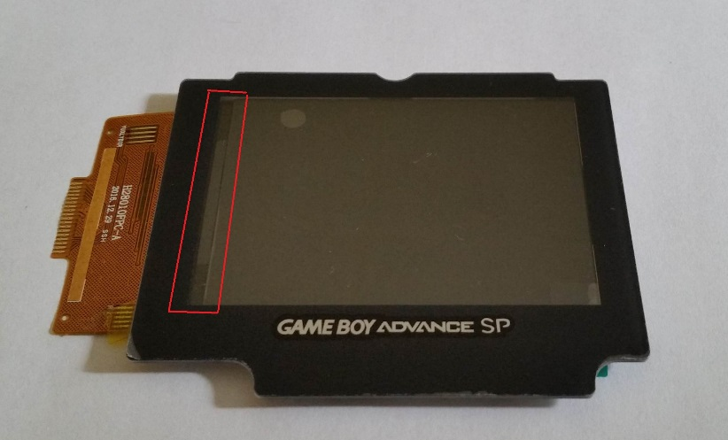

Figure 1 - 2.8in screen behind protector

The area highlighted in red is non-active screen area on the 2.8in screen. The screen does not completely fill the opening in the protector, so there will always be a gap. This looks better when it is centered within the opening, and is not difficult to put a few small black strips of electrical tape to cover the exposed area.

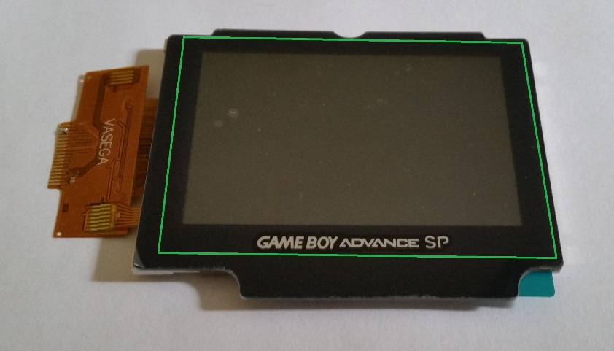

Figure 2 - 3.2in screen behind protector

The 3.2in screen nicely fills the entire opening in the protector. The green outline shows where the actual edges of the screen fall. It is nice to have the entire opening filled, but you will lose pixels around the edge of the screen when you set the proper overscan settings. On a 320x240 resolution screen, all pixels are valuable!

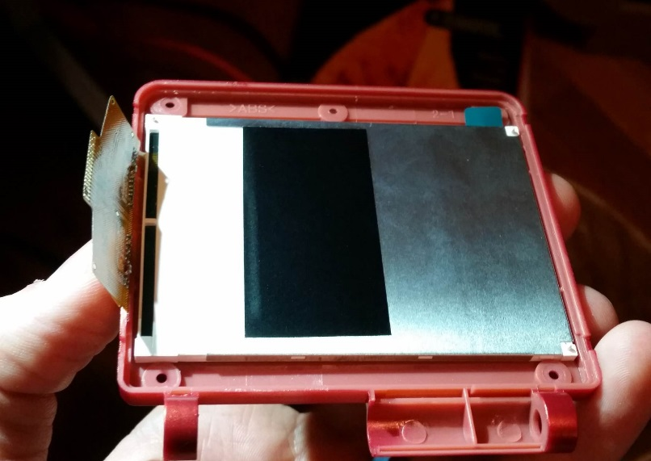

Figure 3 - 3.2in screen, front of screen shell

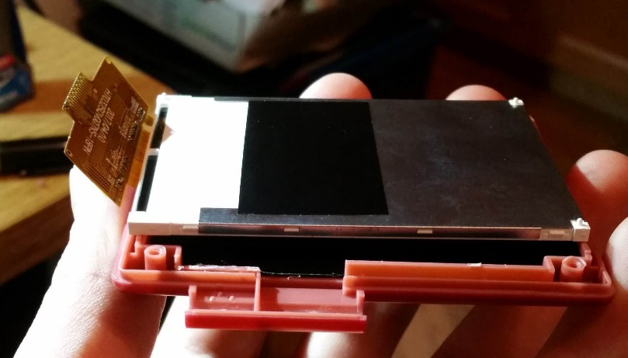

Figure 4 - 3.2in screen, back of screen shell

The 3.2 inch screen fits perfectly in the front part of the screen shell, but will require some trimming of the back of the shell to get it to fit properly.

So again, more tradeoffs, but nothing too difficult to overcome.

### Audio Option

|  |  |  |
| --- | --- | --- |
| **Option** | **Pros** | **Cons** |
| Install headphone jack? | You have a headphone jack | Extra hole needs to be cut in the side of the case. This ruins the stock look of the case |

### Button Option

|  |  |  |
| --- | --- | --- |
| **Option** | **Pros** | **Cons** |
| Add X and Y buttons? | Have full buttons for SNES emulation | Need to cut holes in the case for these buttons. Can be difficult to make it look nice, so ruins the stock look of the case |
| What type of buttons to use? | If you choose to do X and Y buttons, you do not need to use the GBA-SP A and B buttons as I do. You can find and use any buttons you wish, as long as they can properly press the tact switches on the AIO board | I have no idea what buttons to tell you to use. I have only used the SP A and B buttons, but I have no doubt someone can find better buttons and do a better job than me! |

**Basic build configuration:**

2.8 in SPI screen, 1500mAh battery, no X and Y buttons, with headphone jack

This is the build configuration I will be detailing in this guide.

**Most difficult build configuration:**

3.5 in composite screen, 2000mAh battery, X and Y buttons, no SD card, no headphone jack

If you want a challenge, this is it! Everything will fit, and it is awesome when it is done, but there is a lot of soldering skill involved. I will not be describing this build here. If you really want a challenge then you can contact me for more details on how to do this build.

## Items Included in the Kit

## Additional Items Needed

The AIO kit contains almost all the necessary electronics for the build. But there are some necessary items that are not included, and are up to the builder to acquire.

### Items needed:

1. GBA SP shell, buttons, etc
   1. The shells all come as a kit, with all the hardware included. On Amazon you can also find the Philips and tri-wing screwdrivers included with the shell
2. Raspberry Pi Zero W and SD card
   1. The W version is important for connectivity to set everything up
3. Battery
   1. A known fitting battery is the 1500mAh 803450 size battery. This is where I purchased mine from: [https://www.ebay.com/itm/3-7V-1500mAh-Lipo-polymer-li-ion-Battery-For-mobile-phone-MP5-c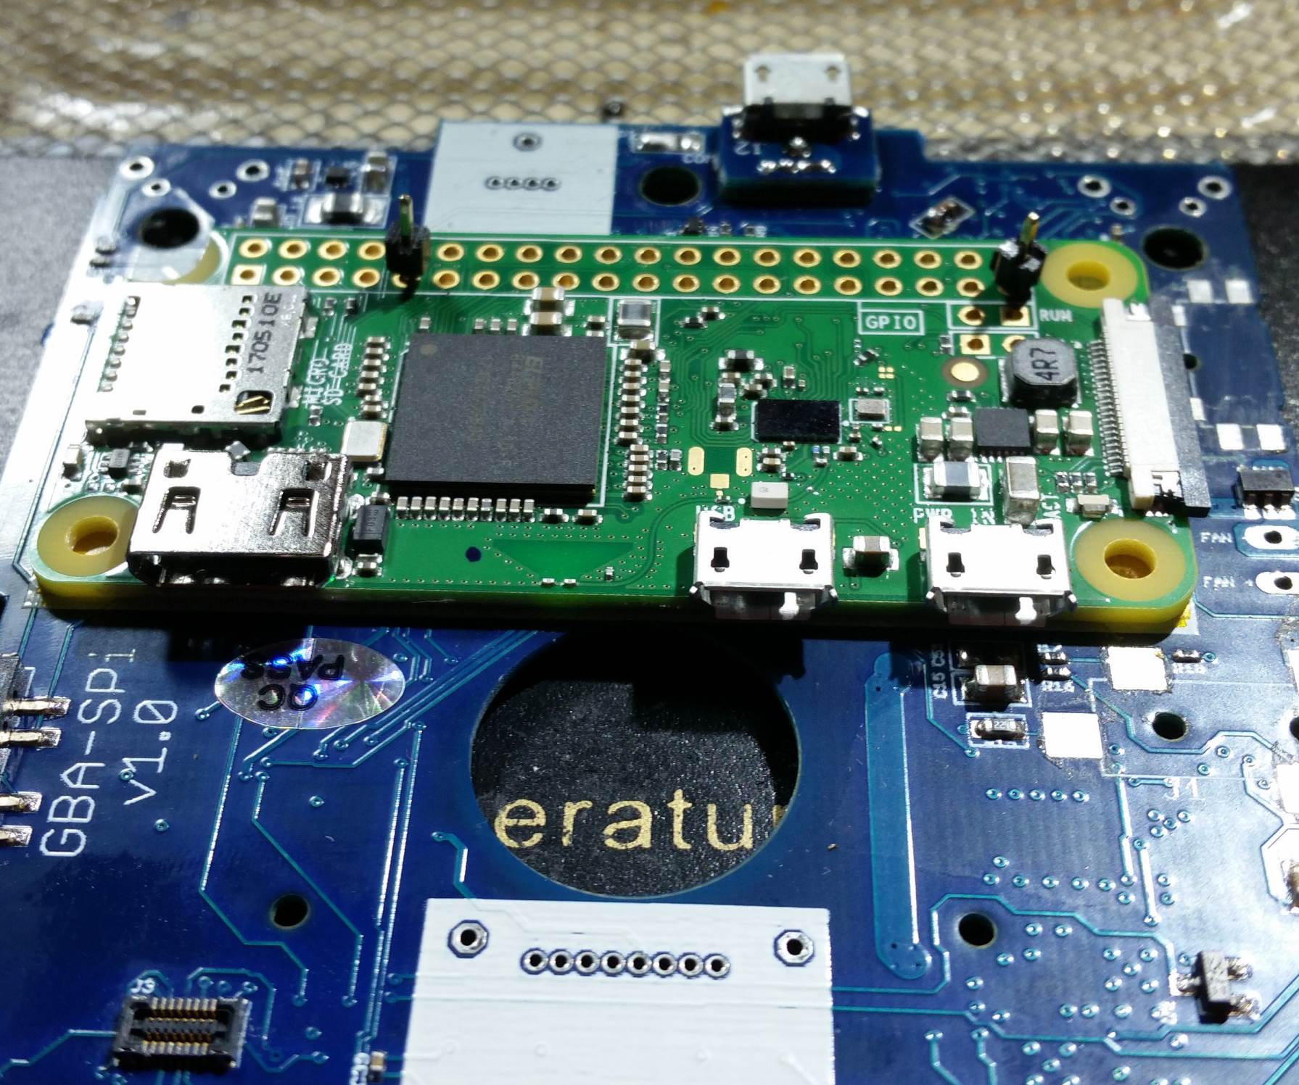amera-PAD-803450/182100726138?ssPageName=STRK%3AMEBIDX%3AIT&_trksid=p2057872.m2749.l2649](https://www.ebay.com/itm/3-7V-1500mAh-Lipo-polymer-li-ion-Battery-For-mobile-phone-MP5-camera-PAD-803450/182100726138?ssPageName=STRK%3AMEBIDX%3AIT&_trksid=p2057872.m2749.l2649)
   2. Bigger batteries will fit, but there are compromises. 2000mAh can be fit, but this doesn’t allow the headphone jack, and connectors need to be desoldered from the Pi
4. Screen
   1. There are many options for a screen to purchase. There is a SPI screen option, or composite screen. I highly recommend using the SPI screen. The screen must be:
      1. Either 2.8 in or 3.2 in
      2. Use the SPI setup for the ILI9341 driver IC
      3. Either the 18-pin solder version, or be mounted to a driver board with all the SPI connections available to solder on wires

These pieces are the bare minimum necessary for this build. This does not include the extra pieces necessary for the X and Y button addition. If you are adding X and Y buttons, you will also need:

1. A second button set (GBA SP A and B buttons if using the provided button wells)
2. The rubber button piece for the A and B buttons (or anything else necessary for your button choices)

## Necessary Tools

Figure 5 - Necessary tools

|  |  |
| --- | --- |
| **Tool** | **Comments** |
| Kapton Tape | Good for everything! Make sure you have plenty of this available |
| Super Glue | Used for holding together the game cart and volume slider |
| Solder | Be sure to get good solder. Review this forum thread by Helder:  http://www.sudomod.com/forum/viewtopic.php?f=34&t=4106 |
| Desoldering braid | Needed to remove solder from AIO board pads |
| No-Clean Flux pen | Keeps all the solder joints clean |
| Sewing needle | For marking X and Y button locations, and aligning riser boards |
| Thumb tack | For making X and Y button mark larger/deeper |
| Small drill bit (1/16 in) | Starting X and Y button holes |
| Step drill bit (with 11/32in or 9mm step) | For cutting X and Y button holes |
| X-acto knife | The case needs a lot of trimming, x-acto knife cuts the soft plastic nicely |
| X-acto refill blades | You’ll go through quite a few! |
| Philips screw driver | For the Philips screws |
| Tri-wing screw driver | The external screws that come with the shells are the Nintendo tri-wing screws |
| Flush cutters | For cutting wires and separating the AIO board |
| Needle nose pliers | For bending leads on the volume slider |

# Build Steps

## Software Installation (SD card prep)

Before soldering the Pi to the AIO board, it’s important to first get the SD card setup, and confirm that everything is functioning properly.

Everything should work well on the latest version of Retropie, which as of right now is version 4.4. So to get everything installed and setup, follow these steps. You will need a micro SD card adapter, a way to connect the Pi to an HDMI screen, a keyboard with the proper USB OTG adapter, and a power supply to power the Pi.

1. Download the latest version of Retropie: <https://retropie.org.uk/download/>
2. Write the Retropie image to your SD card (use win32diskimager or something similar, there are lots of tutorials available on how to get Retropie onto your SD card)
3. Insert the SD card into the Pi, plug in the keyboard, HDMI, and then power
4. Let everything expand and reboot. Once Retropie fully boots, you should be presented with the controller setup dialog.
   1. Map the controller keys to these keyboard keys (basically identical letters on the keyboard)
      1. Up = Up
      2. Down = Down
      3. Left = Left
      4. Right = Right
      5. Start = Enter
      6. Select = Right Shift
      7. A = A
      8. B = B
      9. X = X
      10. Y=Y
      11. Left Shoulder = L
      12. Right Shoulder = R
      13. Skip the rest of the inputs (hold down the Enter key is easiest)
      14. Hot Key = Right Shift (the select button)
5. Connect to WiFi
   1. Go into Configuration (use the A key) and select WiFi setup
   2. A prompt should come up saying it needs your WiFi country
      1. Select Yes, scroll down to Localisation Options, select Change Wi-Fi Country, and select your country. Then select finish to return to the WiFi setup
   3. Select Connect to WiFi network, choose your home network, and type in your password
   4. Once that’s done, select Finish to return to the Retropie menu
6. In the Retropie configuration menu, select Raspi-Config
   1. Select Interfacing Options
      1. Select Serial, and say No to having the login shell accessible over serial
      2. Select Yes to enable the serial port hardware
      3. Select SSH, and enable the SSH server (this is needed for easy ROM transfers over WiFi)
   2. Go to Finish to exit Raspi-Config
      1. Select Yes to reboot
7. Once it has rebooted and you’re back at the main menu, press F4 to go to the command line. It’s time to install the necessary custom code pieces. Type the following commands:
   1. git clone <https://github.com/codeman0624/GBA-SPi>
   2. cd GBA-SPi/Setup
   3. sudo chmod 777 Installer.sh
   4. sudo ./Installer.sh
   5. When it’s all done, choose yes to reboot

## Raspberry Pi Prep

First let’s get the Pi prepared. The upper left corner of the board needs to be cut out. Just remove the area of the mounting hole, and you’re safe. Like the picture below:

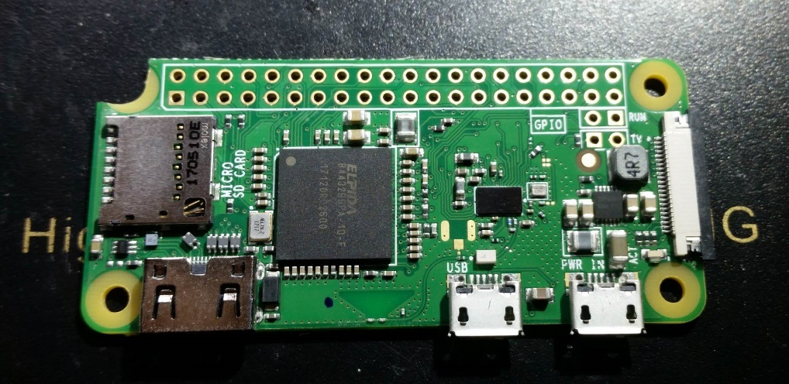

Figure 6 - Remove corner of the Pi

Next take a sharp x-acto knife and trim a small amount of the USB pad shown in the picture below. Only need to remove ~0.5mm, just enough to keep the pad away from the ground connection next to it.

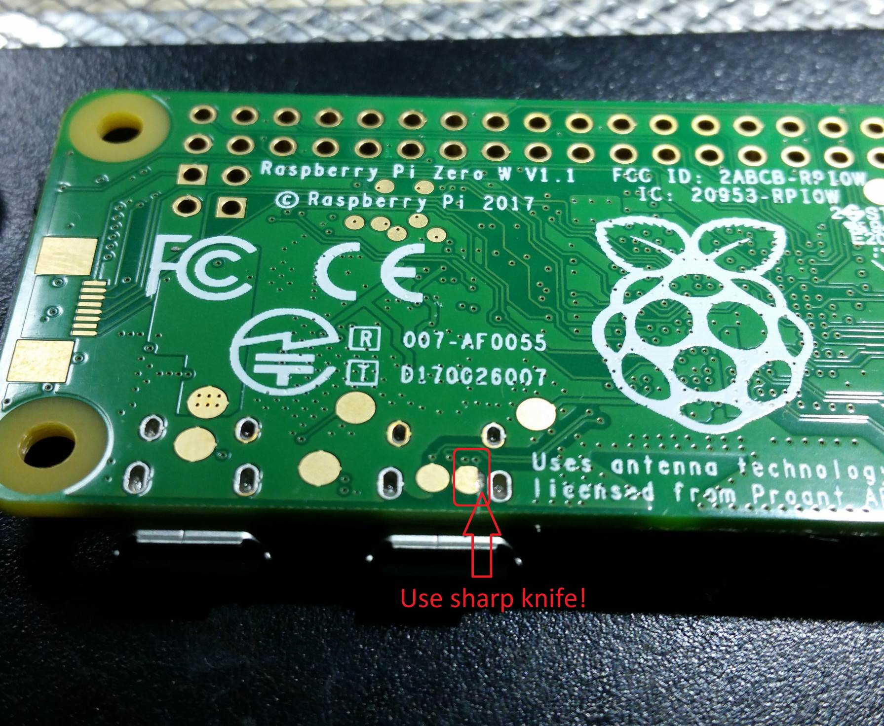

Figure 7 - Trim Pi USB pad

Next put a piece of Kapton tape over the back of the Pi. Using a sharp knife, open up the areas around the USB pads.

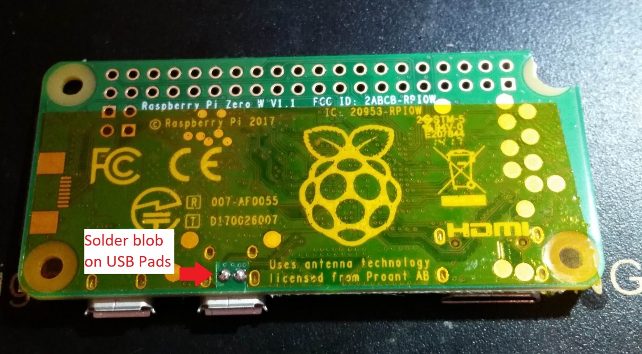

Figure 8 - Pi Kapton tape and solder blobs

## Preparing components

A few of the electronics components need to be prepared, so we might as well get that out of the way first.

### Volume Slider

First take the volume slider, and using the needle-nose pliers, gently bend the pins in the back so they are flat. Leave the middle pin vertical. This is shown in the picture below

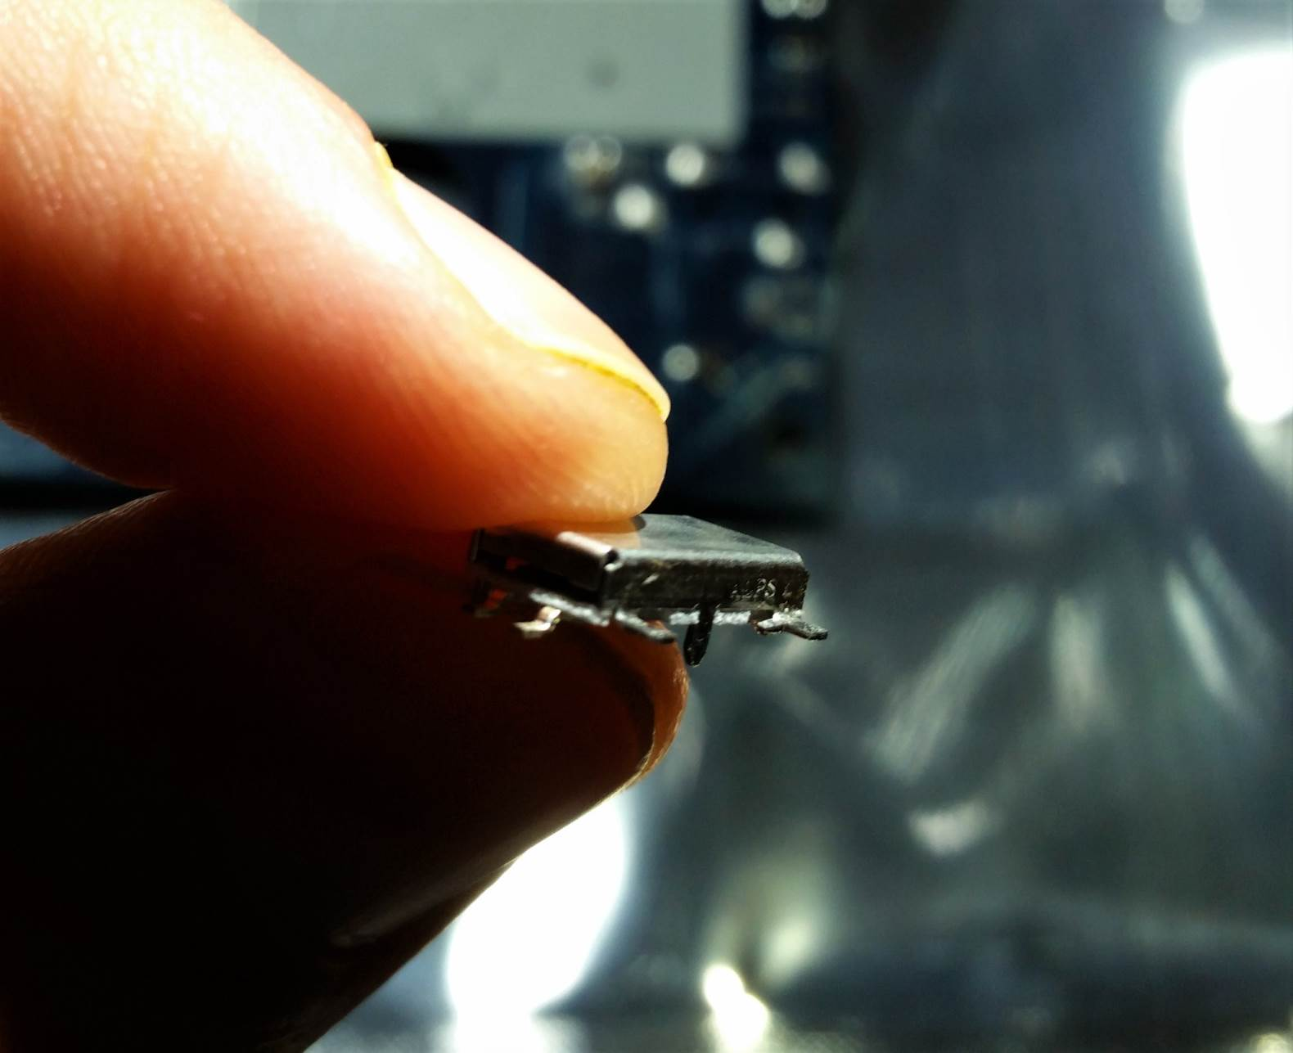

Figure 9 - Bend volume slider pins

Next use your knife to trim the plastic protruding off the back of the volume slider plastic piece, as shown below.

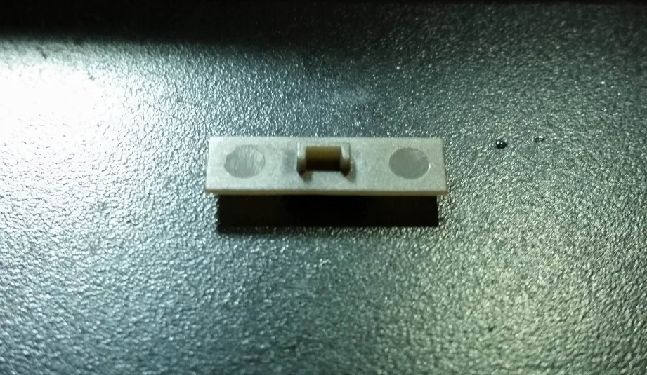

Figure 10 - Volume slider plastic before trimming

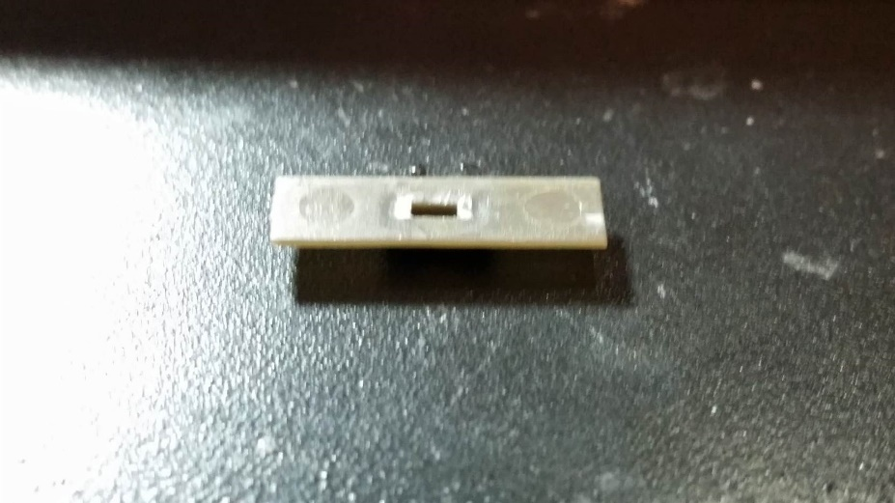

Figure 11 - Volume slider plastic after trimming

Then put a small bit of super glue in and around the hole of the plastic piece. Be careful not to use too much, if the glue oozes out and accidentally glues the slider so that it can’t move, you’ll be in trouble.

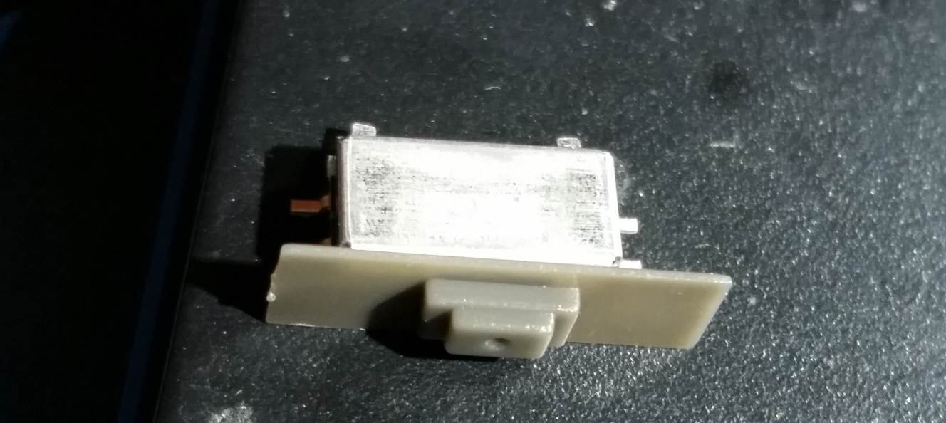

Figure 12 - Volume slider pieces glued

### USB Port

The USB port is easy to modify. Just trim the small metal bits protruding from the bottom. These normally would go through holes in the PCB, but we don’t have space to put those holes, so they need to be trimmed.

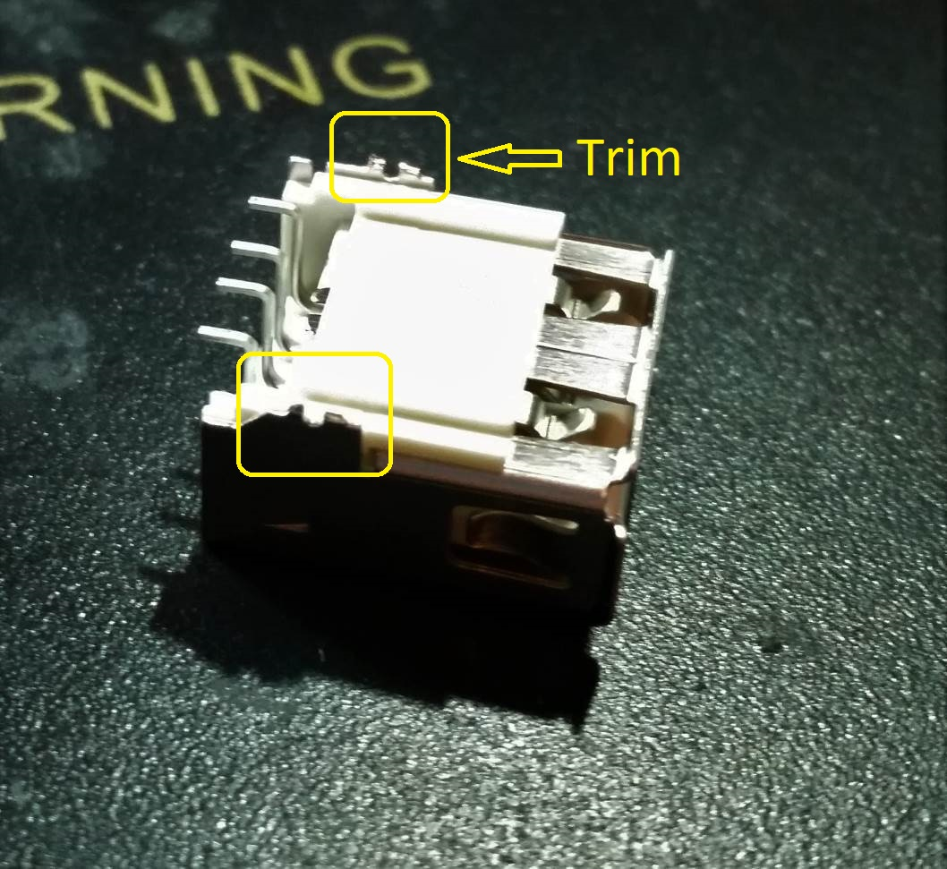

Figure 13 - Trim USB port metal

## Case Modifications

The case modifications require a Dremel, a **sharp** x-acto knife, and some patience. This section will not cover what is required for the X and Y button modifications, just what is required to get everything to fit properly.

### Front shell

The front part of the shell does not need much for modifications. First off trim this tiny piece of plastic circled in the picture below. It interferes with one of the components on the AIO board

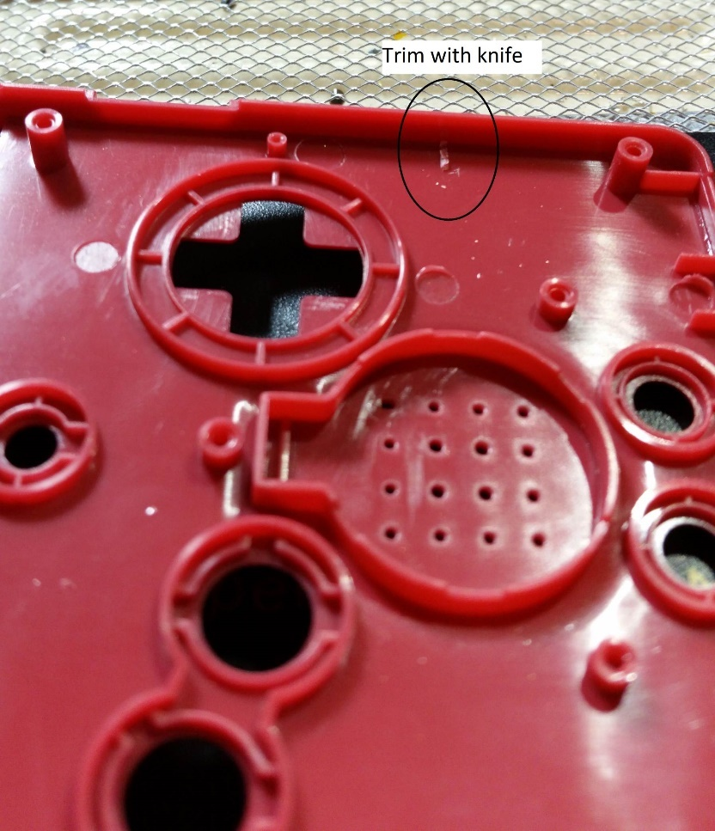

Figure 14 - Front shell, trim interfering plastic

Next use the knife to open up a wider hole for the ribbon cable. Be sure not to cut too far! I made that mistake in the picture below, and this messed up an important piece on the inside of the shell that I needed to repair.

Don’t go beyond the left-right boundaries of the existing hole. Just open it up top-bottom.

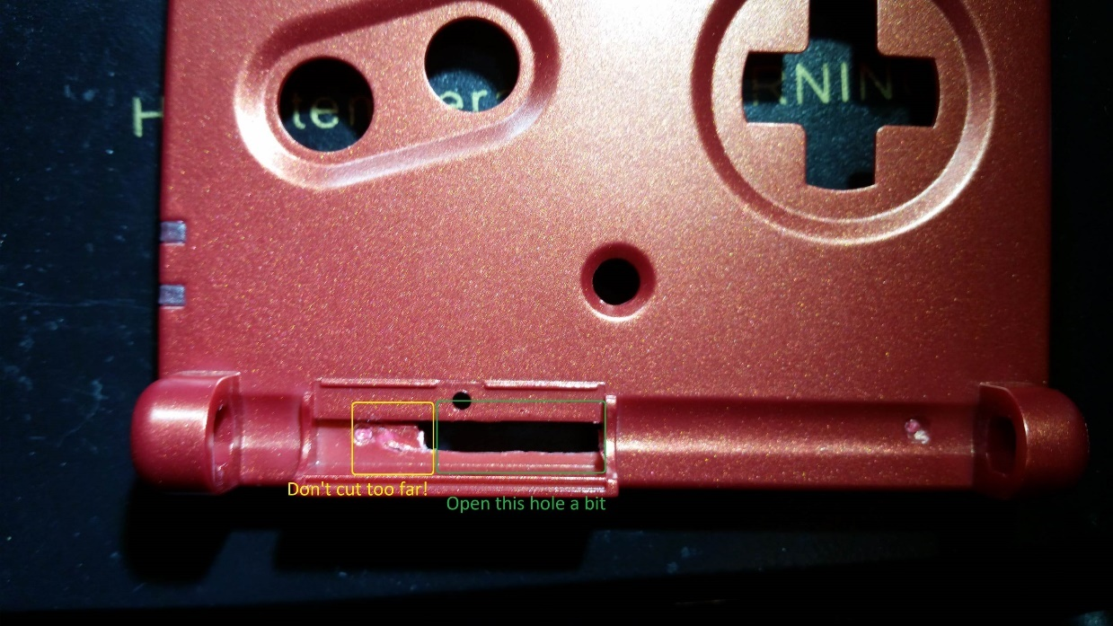

Figure 15 - Front shell, open ribbon cable hole

That’s it for modifying the front half of the shell, not much to it. But don’t hide this part away just yet, we’ll need to come back to this soon for X and Y button markings.

### Back shell

The back shell needs more careful modifications. The markings in the picture below show the area to make the rough Dremel cutout.

Be careful of the points circled! These are the holders for the L and R button springs, so be very careful around these, they can’t be replaced or repaired.

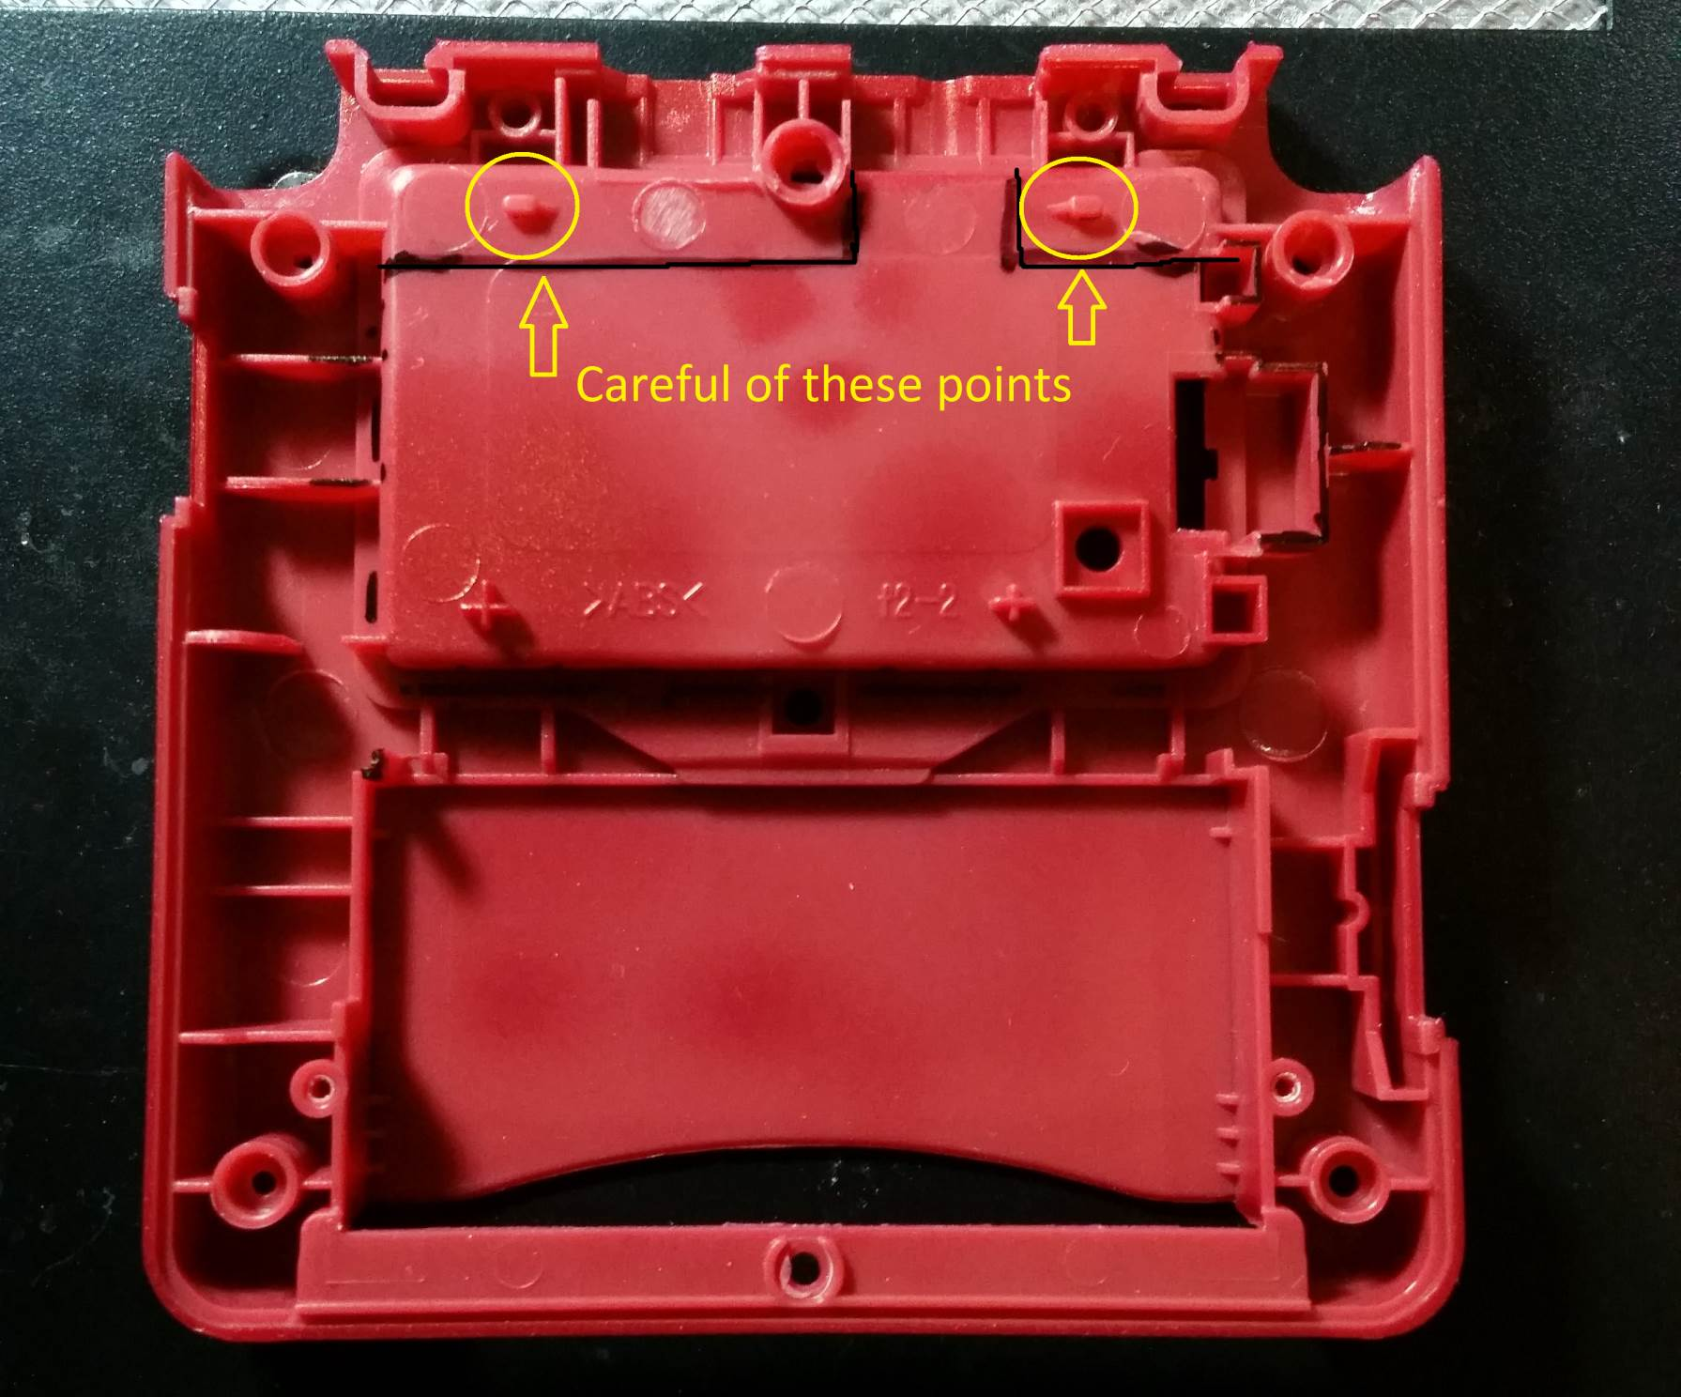

Figure 16 - Back shell cutout markings

The finished result should look like the picture below.

The red arrow shows the point I used when determining how thin to leave the plastic. You do not want to go any thinner than this point, so you can still use the screw for mounting the back cover.

The yellow sections show where it’s best to trim with a knife. Be patient with the screw mount in the upper right. It can be difficult to cut through. But just shave it small layers at a time, and eventually you’ll get it flush. **Do not cut past this point**, otherwise the case screw will not have anything to hold.

The black section is where the USB port will go, this will require more careful shaving.

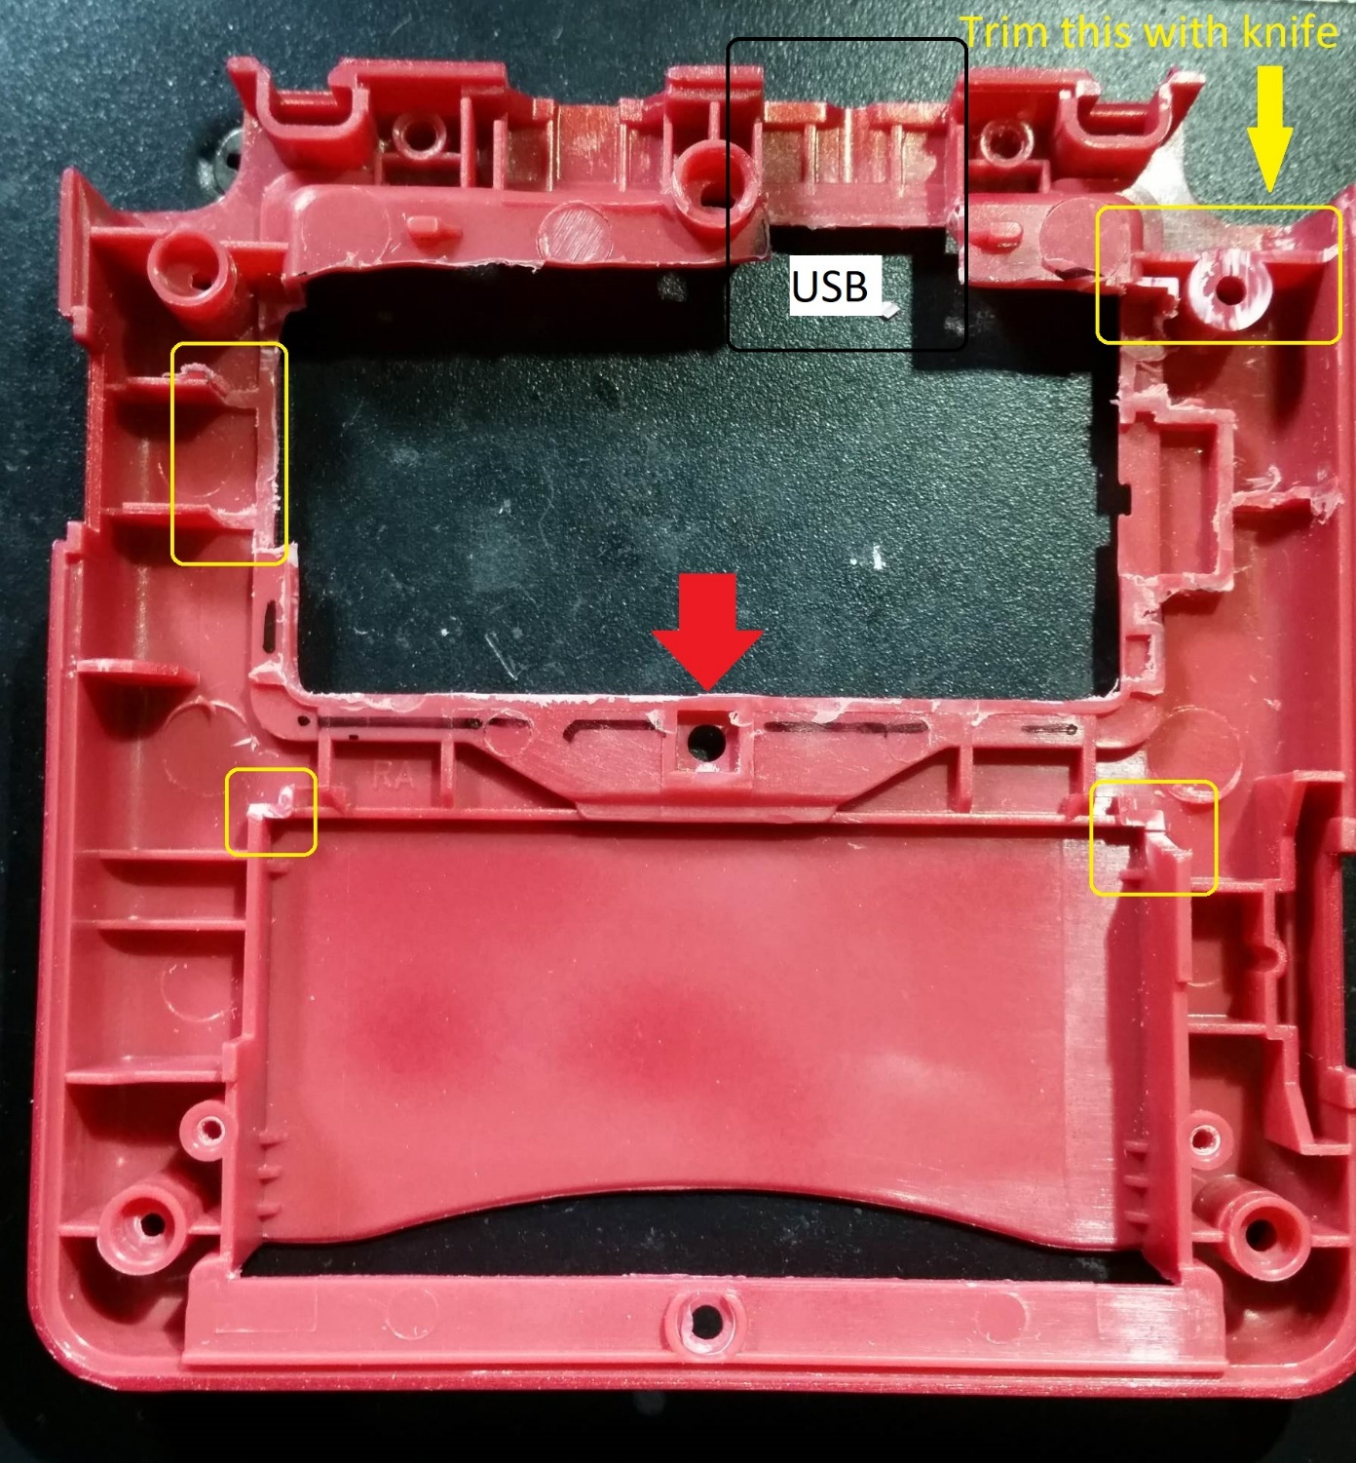

Figure 17 - Back shell, cutting results

Next we need to prepare for the USB port to fit. Start by shaving down the plastic shown in the picture below. Use a sharp knife, and just remove small layers at a time. Be careful not to cut all the way through. The goal is to just make this area thinner, so the USB port will fit better.

In the picture below you can see where it has been shaved slightly. But the amount shown is not enough.

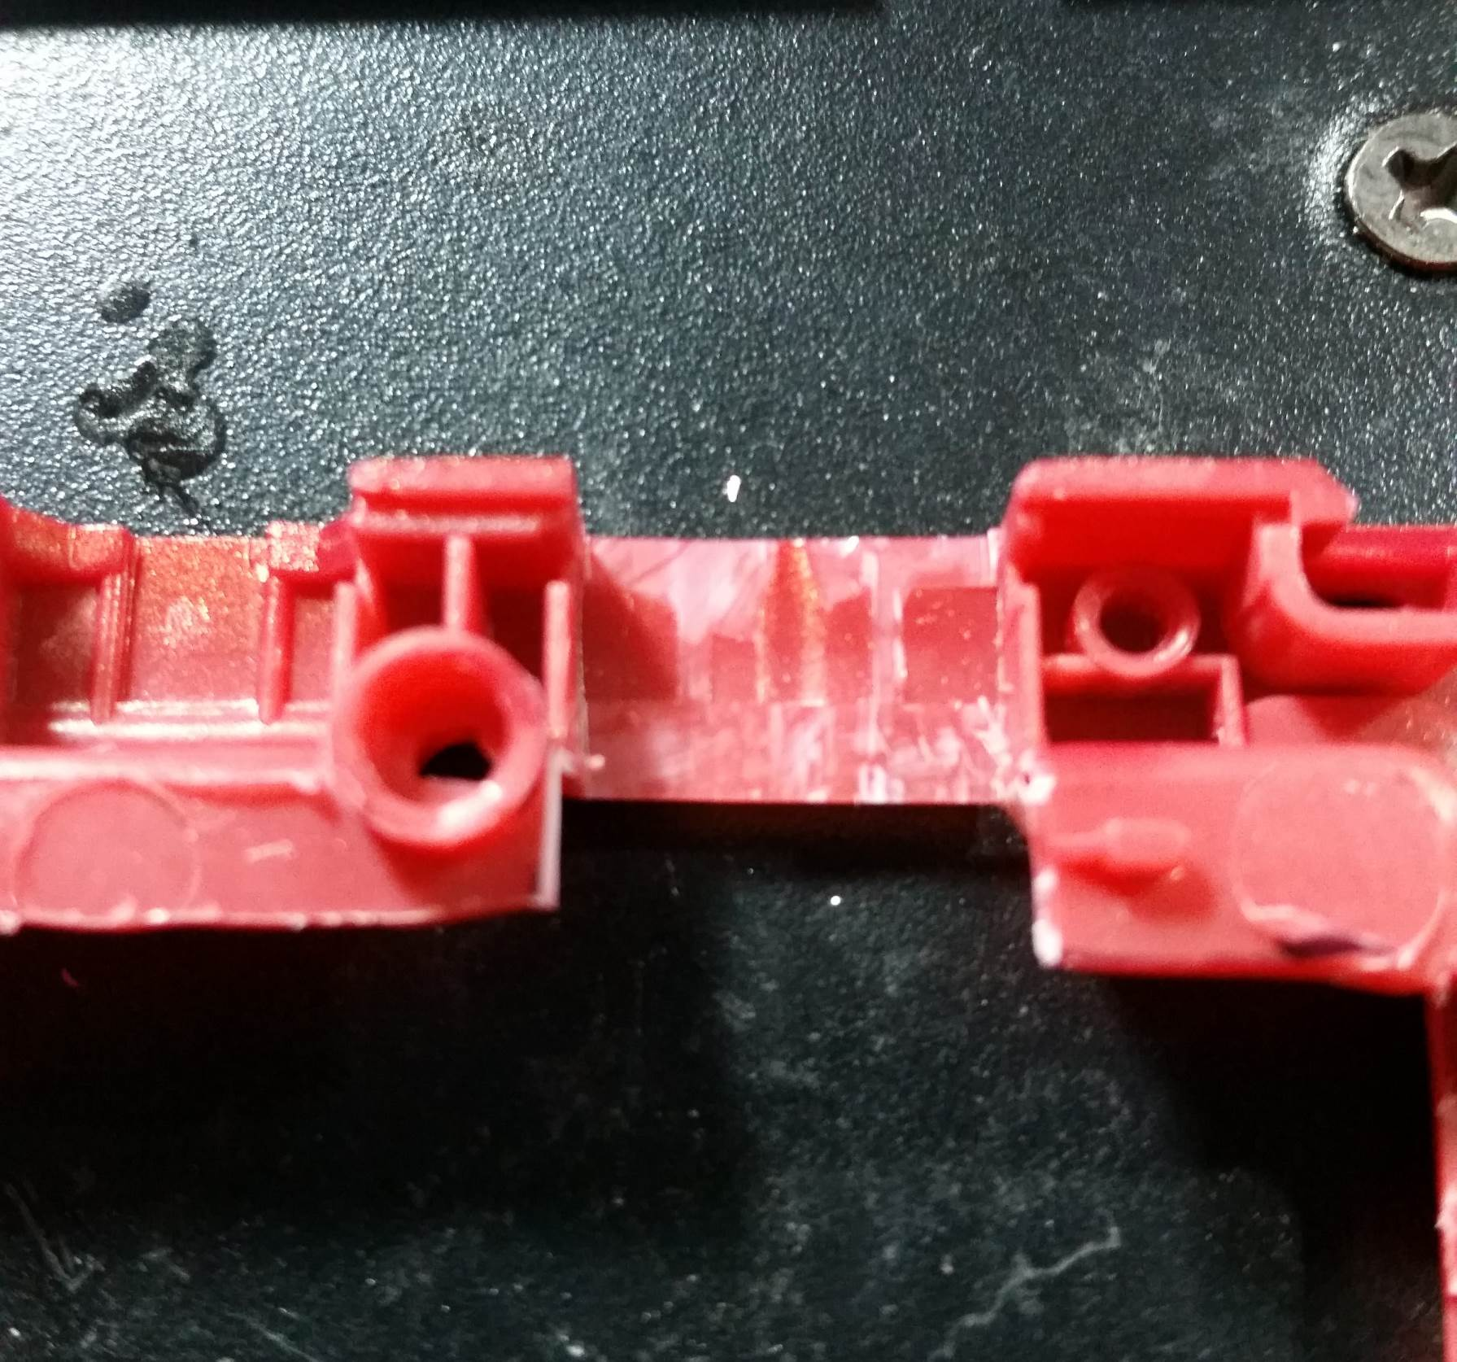

Figure 18 - Shave plastic for USB port

The USB port is just barely too wide, maybe by 1mm max. Put the USB port up to the opening, and check where the rest of the plastic needs to be trimmed.

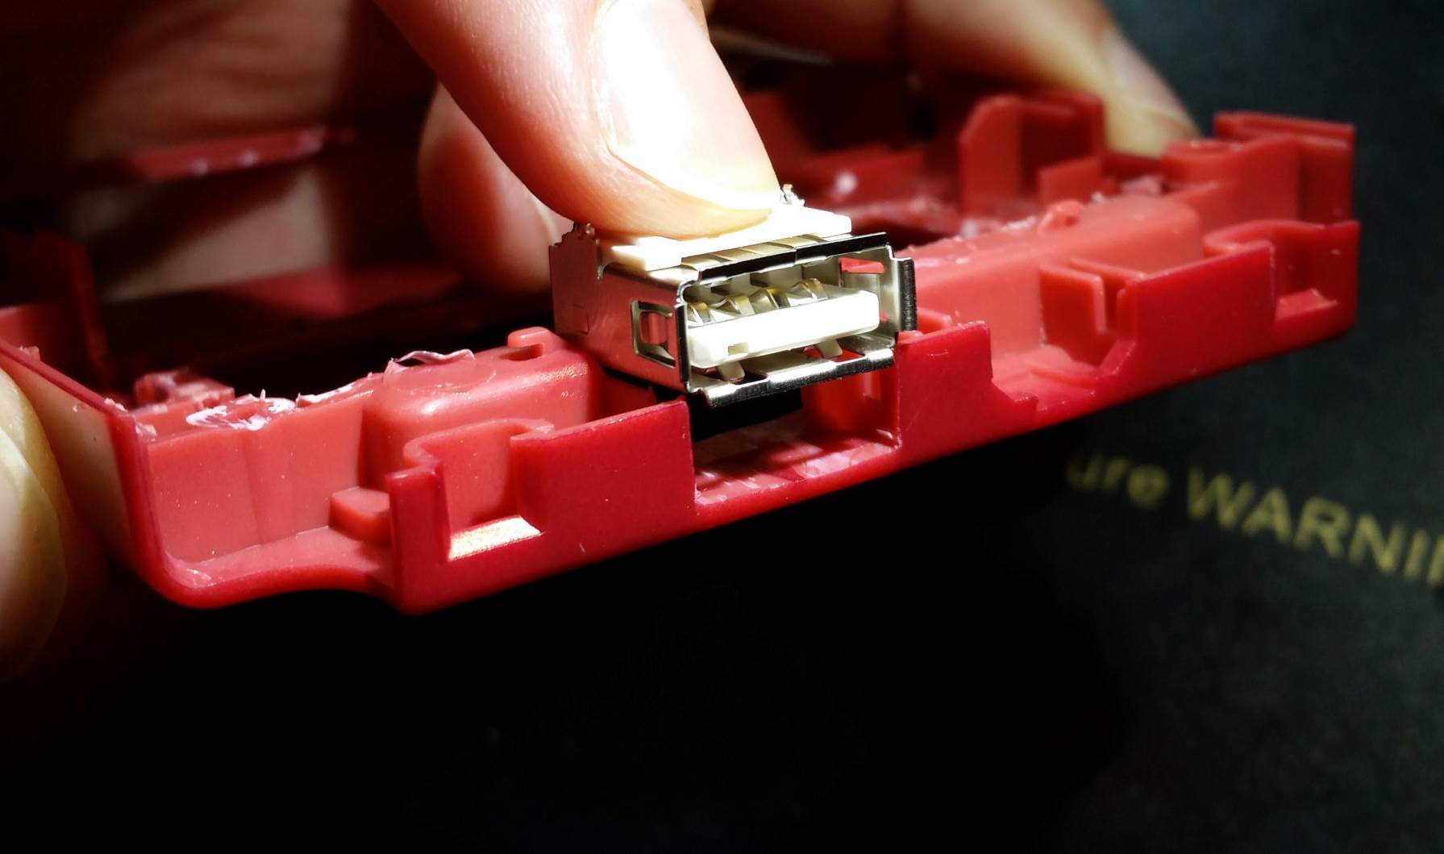

Figure 19 - Check where to trim for USB port

SLOWLY and CAREFULLY trim the necessary plastic to open up the USB port. I mentioned patience is necessary, this is when to put that into practice. Cutting too far will ruin your day. So slowly trim the plastic until the USB port fits like in the picture below.

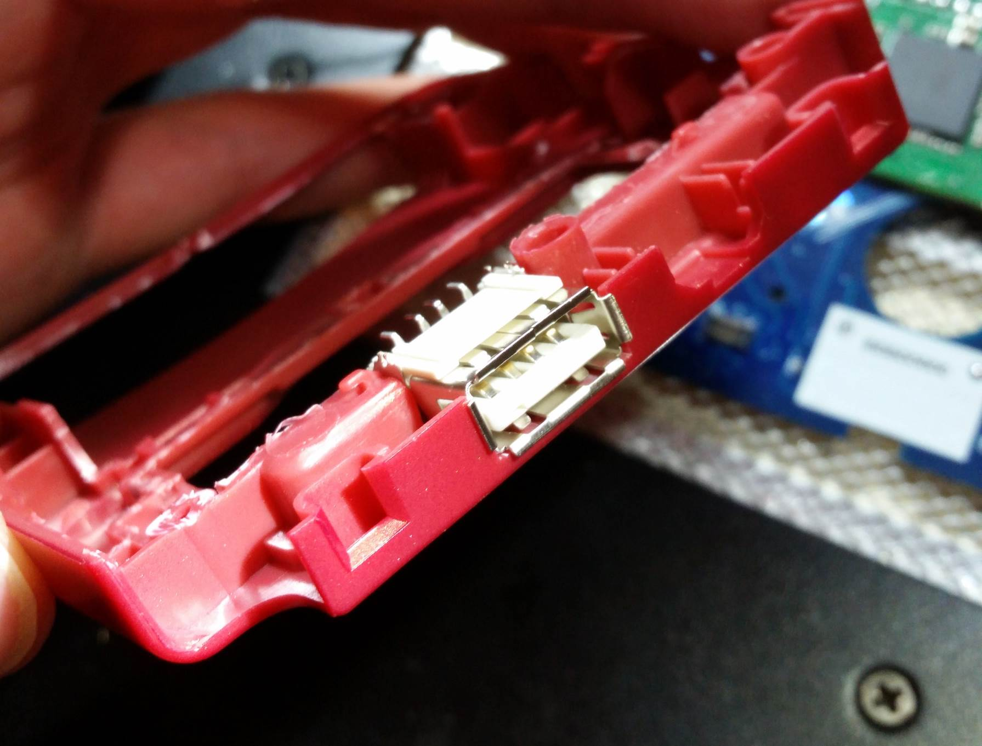

Figure 20 - USB port fit into shell opening

### Screen shell

The shell for the screen is easy to modify. Just shave the small section shown in the picture below. This is simply so the ribbon cable coming through here does not get pinched.

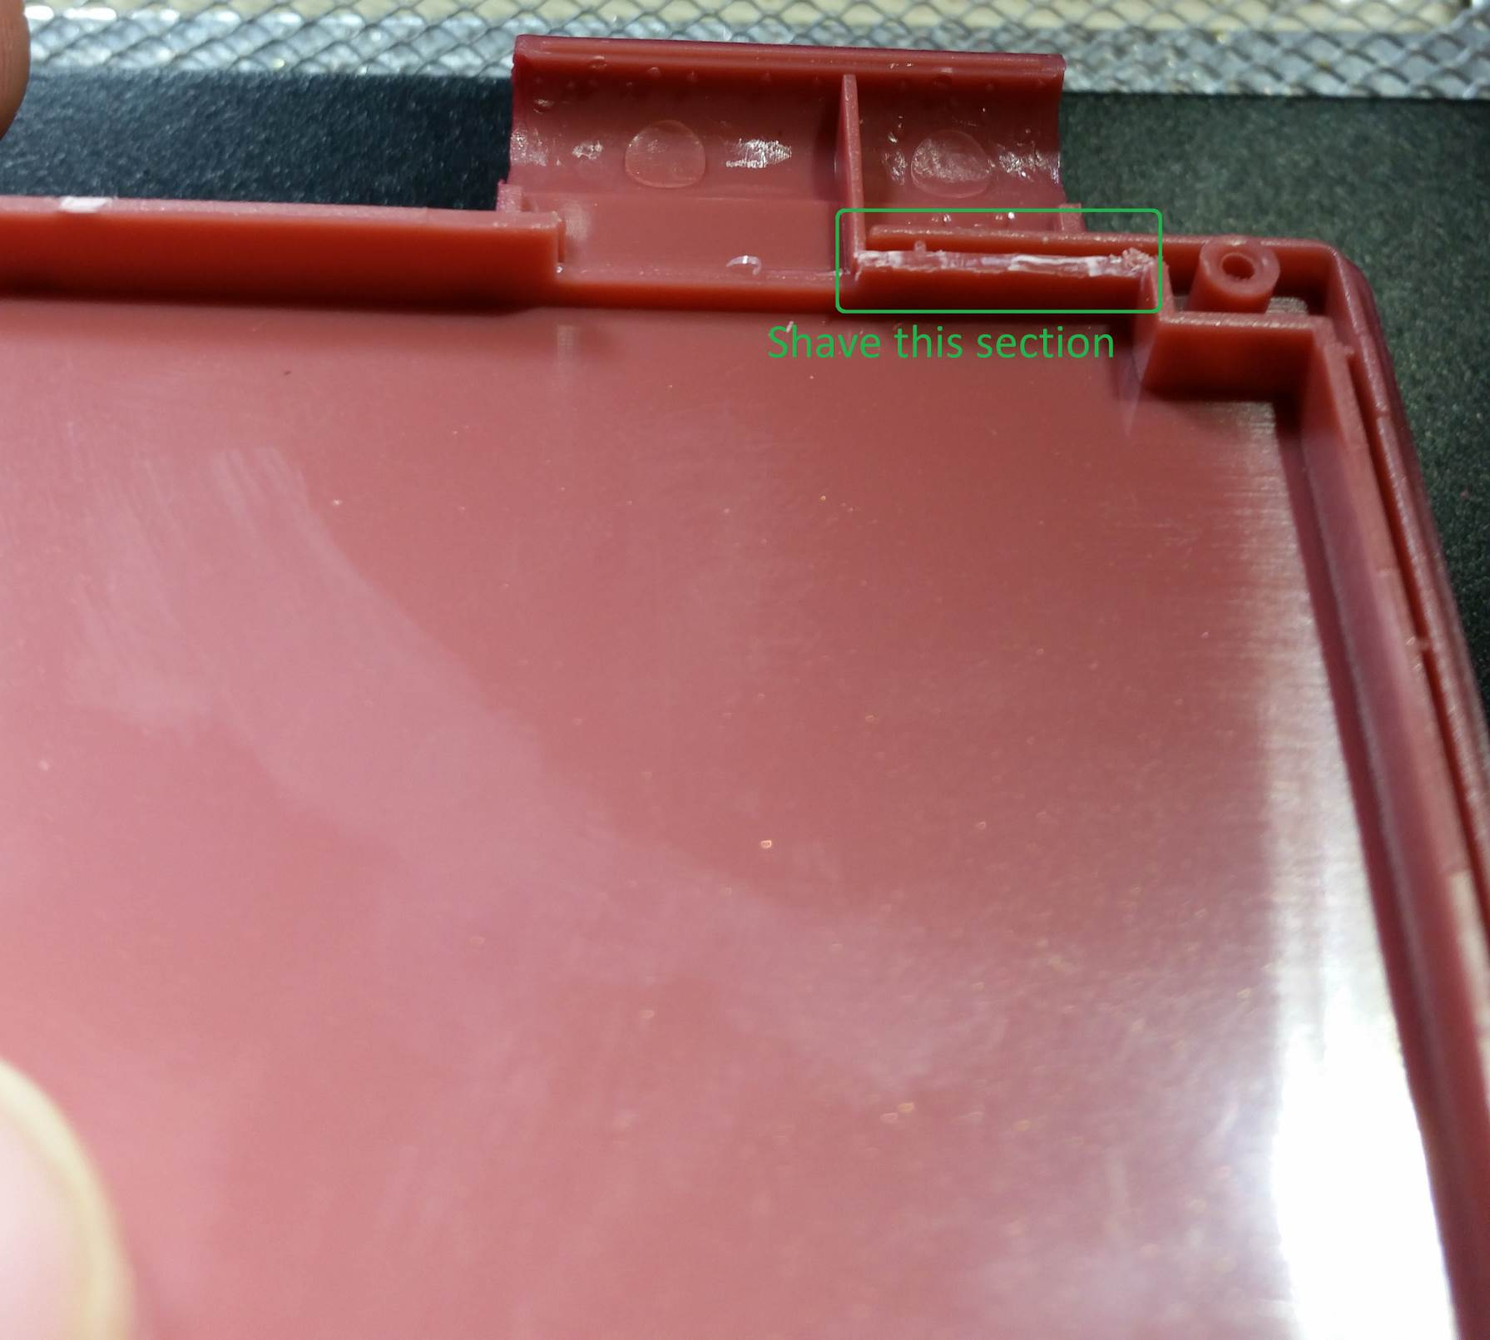

Figure 21 - Screen shell modification

## Preparing the AIO board

Finally it’s time to move on to the AIO board itself. First step is to use the flush cutters to separate all the pieces.

### Separating PCB pieces

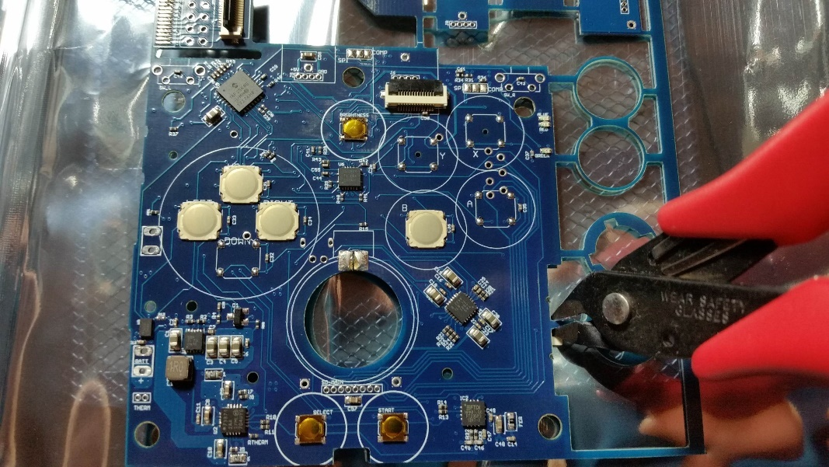

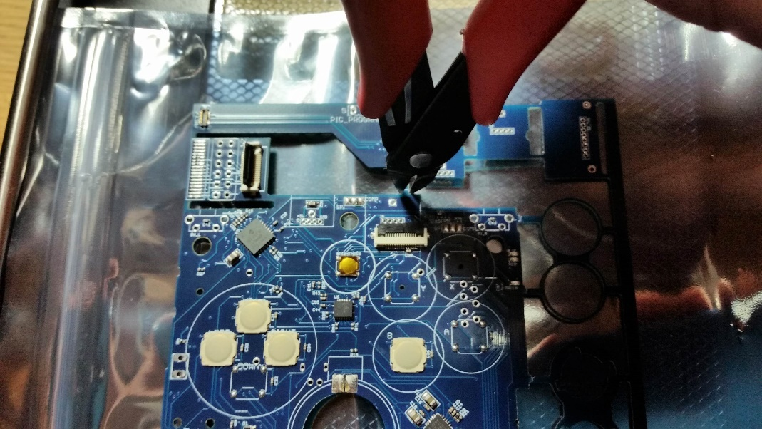

Figure 22 - Separate the board pieces

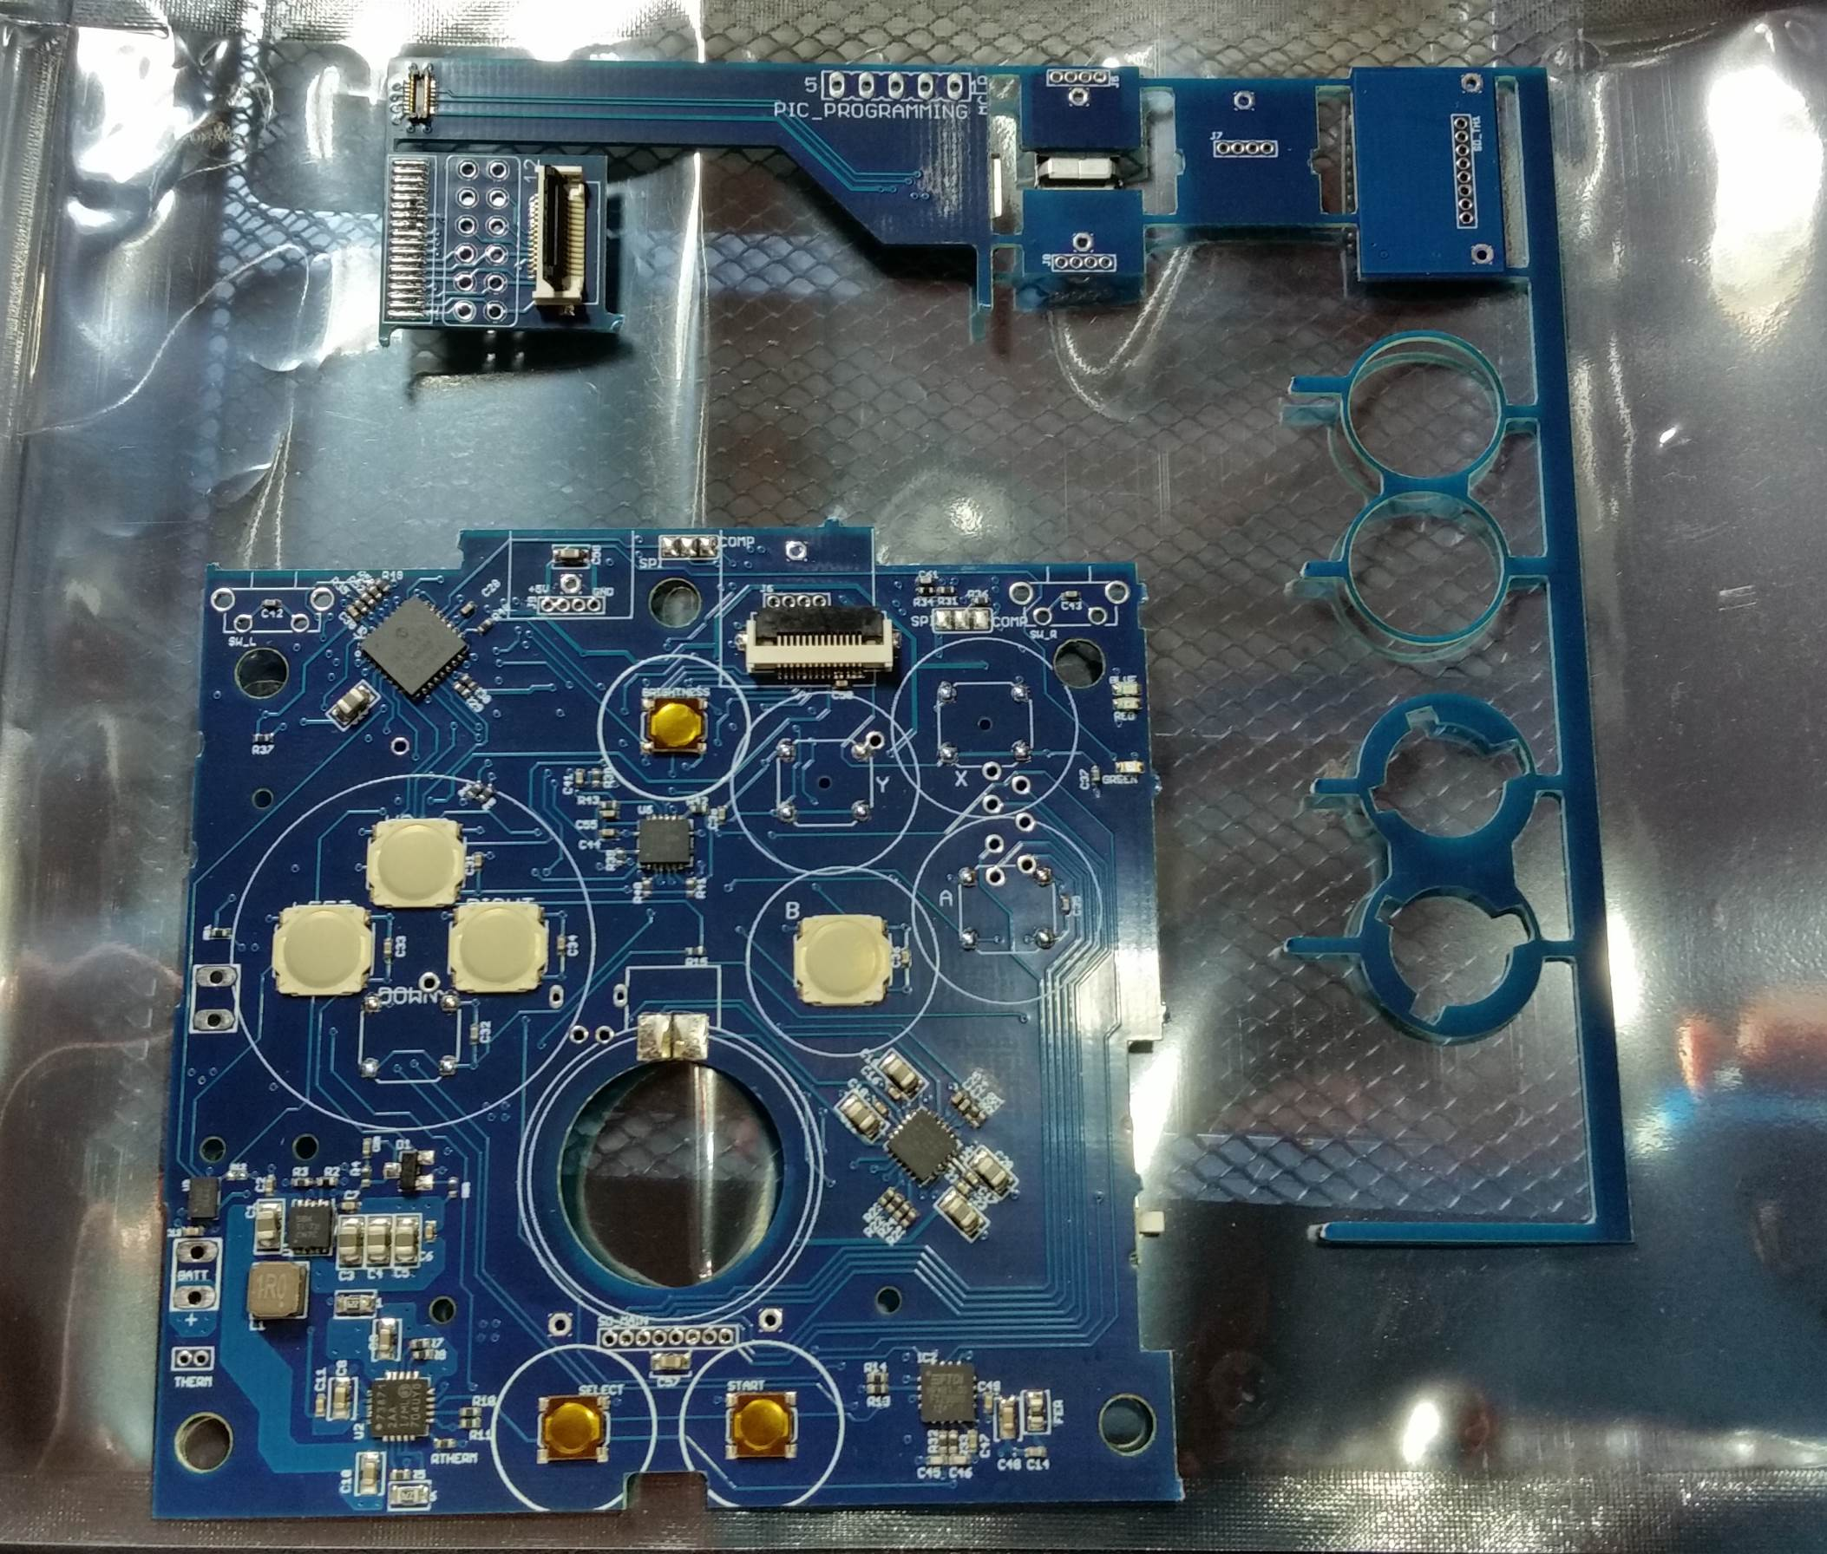

Figure 23 - Separated main board

Once the main board has been separated, carefully clip the pieces holding the rest of the board parts together. **Be careful around the thin circle pieces!** They are fragile and will break easily.

### Trim extra PCB pieces

Once the pieces are separated, use the flush cutters to remove the small nubs of PCB that is left over (avoid the circle pieces for now). Don’t be afraid to cut close to the board, as shown below

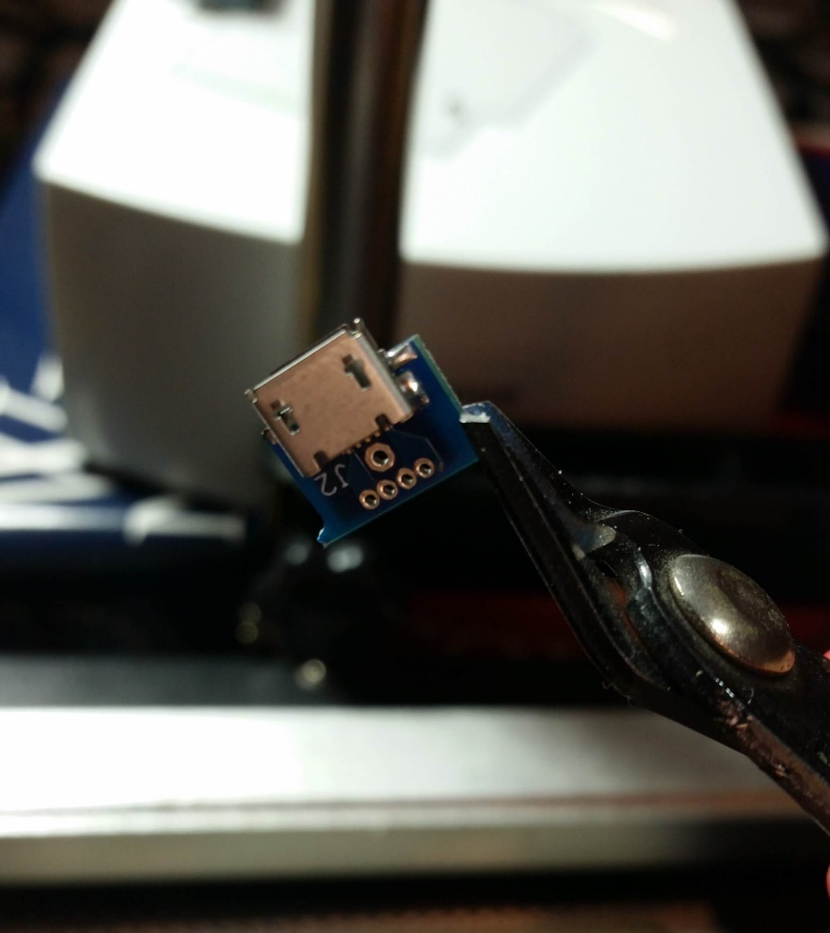

Figure 24 - Cut PCB nubs

Be sure to remove these extra PCB pieces from the main board as well, try to get them as smooth as possible, as shown in the pictures below.

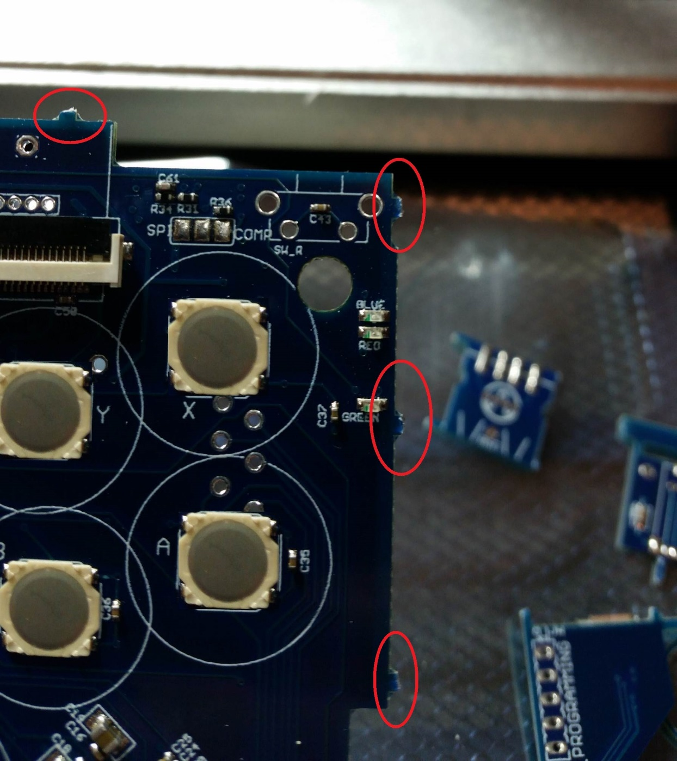

Figure 25 - PCB pieces to remove

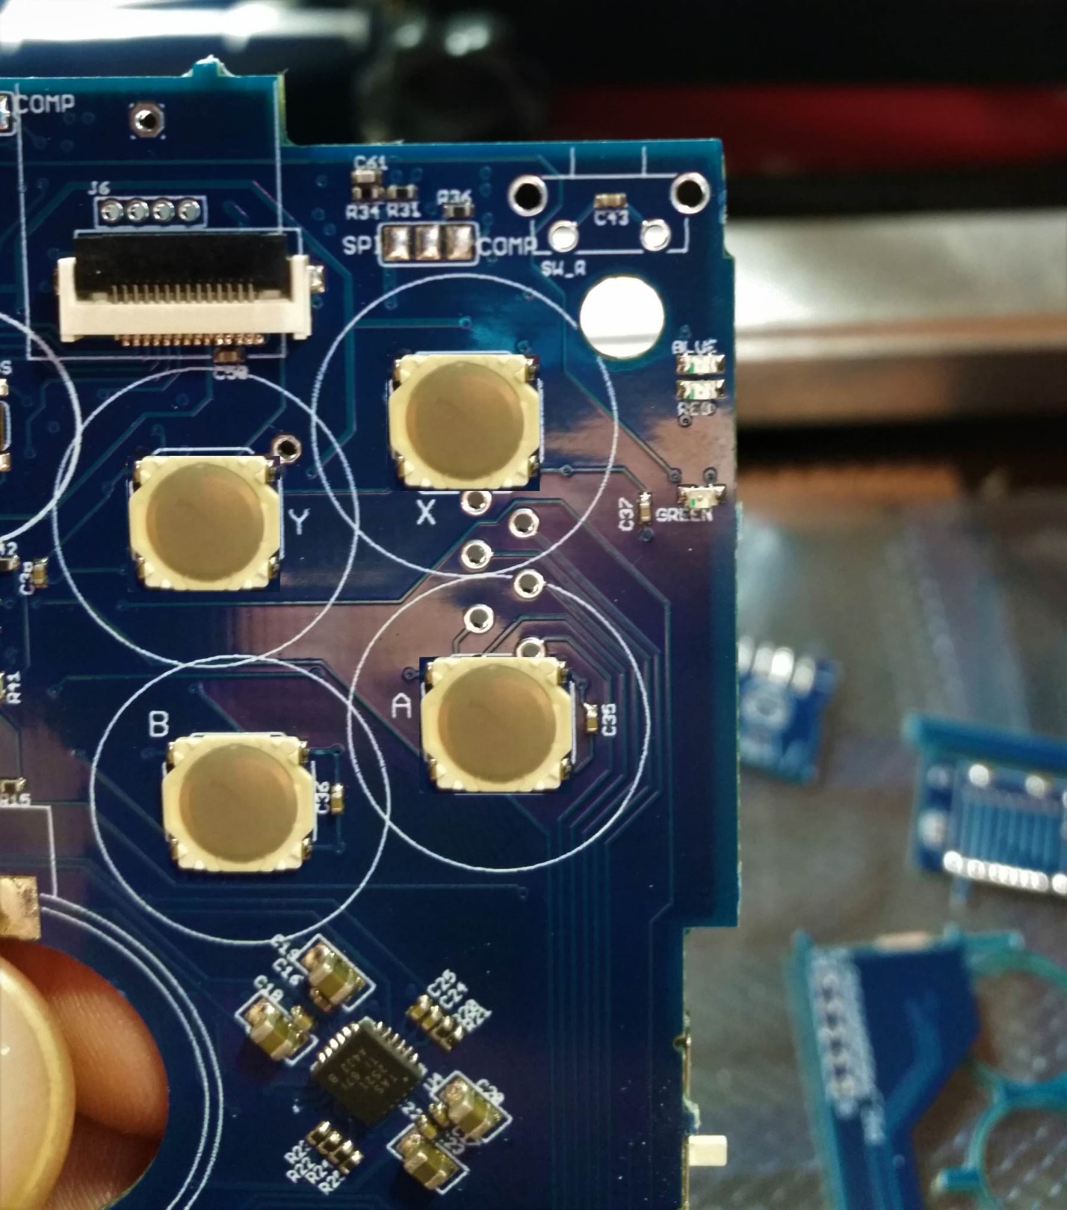

Figure 26 - Smooth PCB after pieces removed

## Desoldering

Some components are not already assembled on the board, but during the assembly process they get some solder blobs on their pads. We need to remove this excess solder so we can properly assemble the components.

To do this, you need some good quality desoldering braid. Then use the braid to desolder all the pads for the volume slide, headphone jack, and the speaker pads. Before and after is shown in the pictures below.

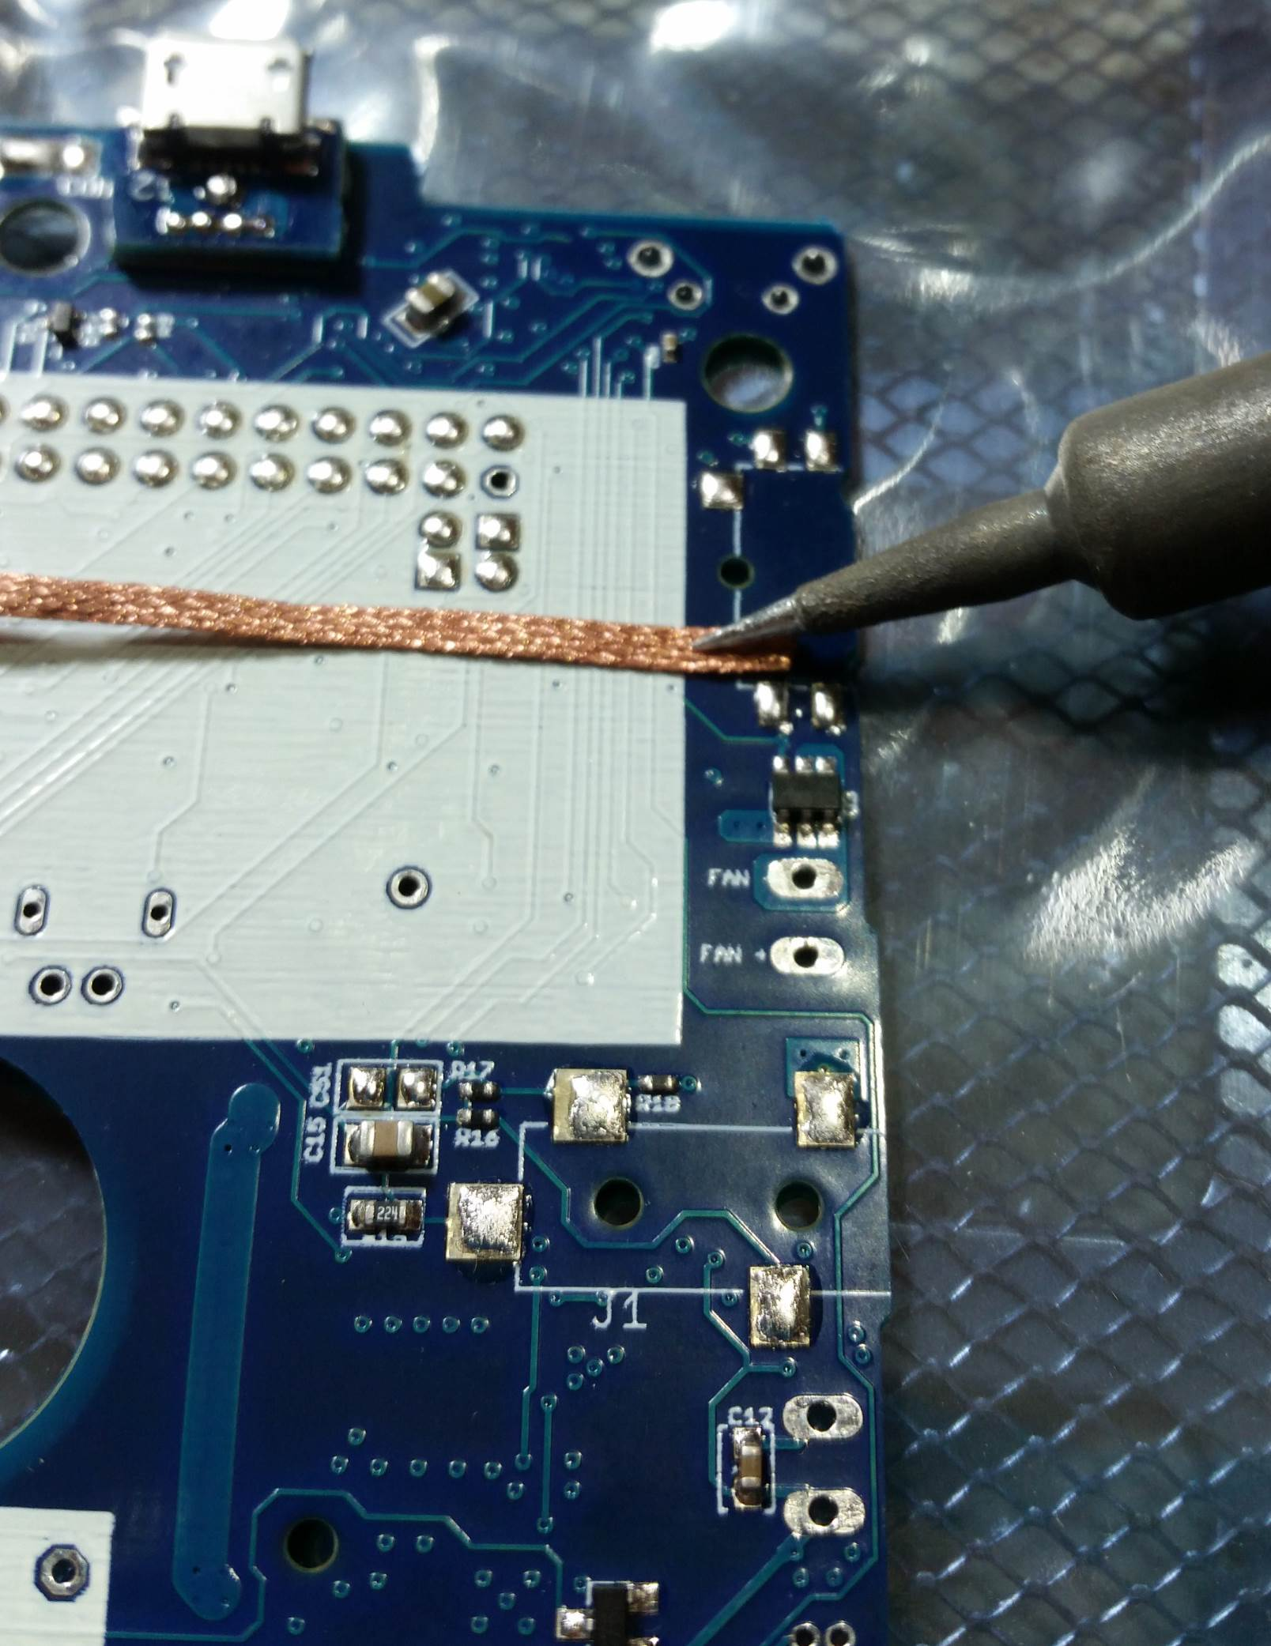

Figure 27 - Desoldering the volume slider

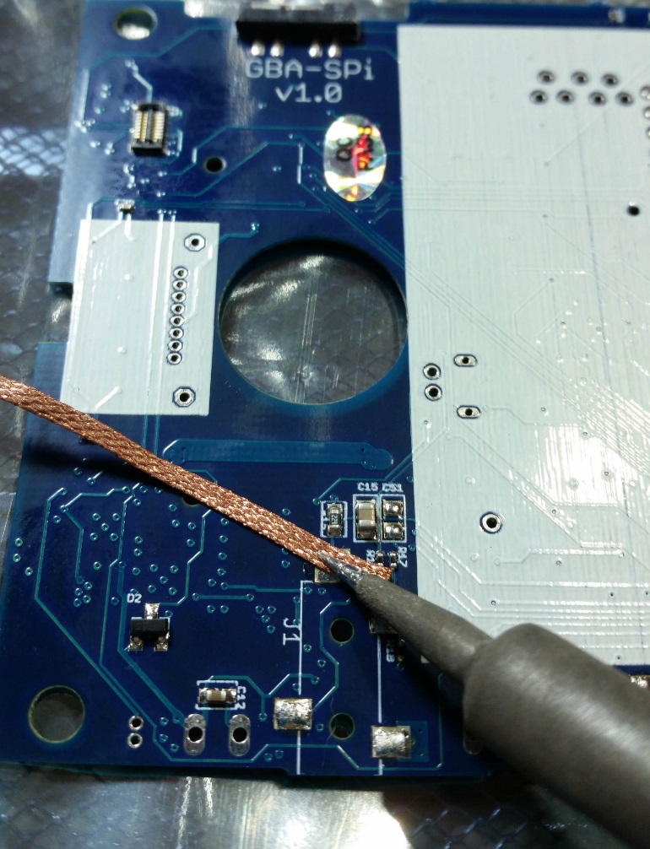

Figure 28 - Desoldering the headphone jack

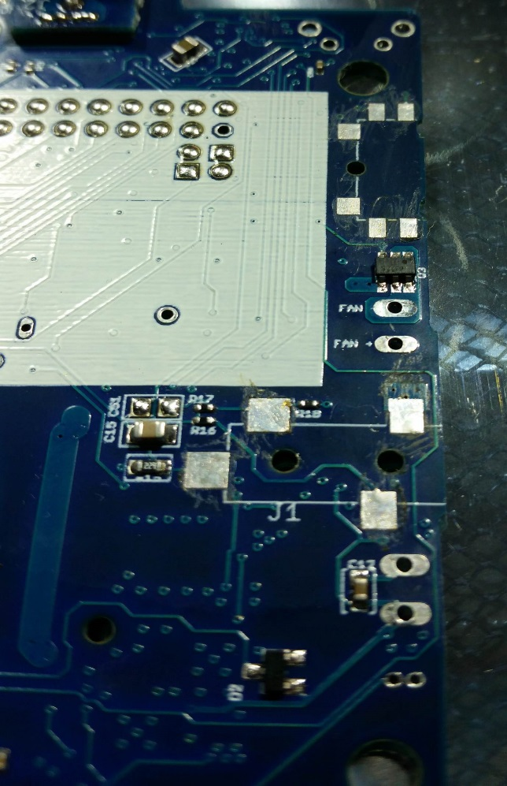

Figure 29 - Solder removed from volume slider and headphone jack

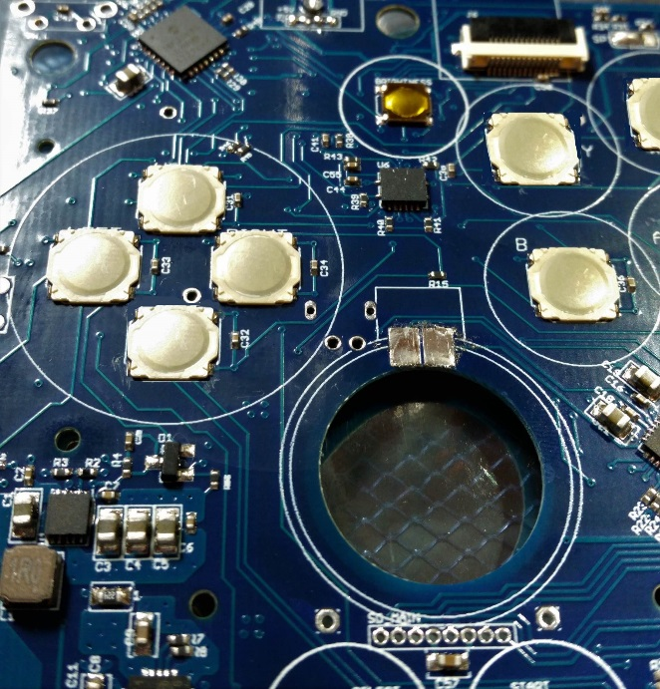

Figure 30 - Solder removed from speaker pads

## Micro USB power port

First thing to assemble on the board is the power port. Power is needed in order to test everything on the board, so this is a good first step.

First cut off a single pin from the provided pin header, as shown in the picture below.

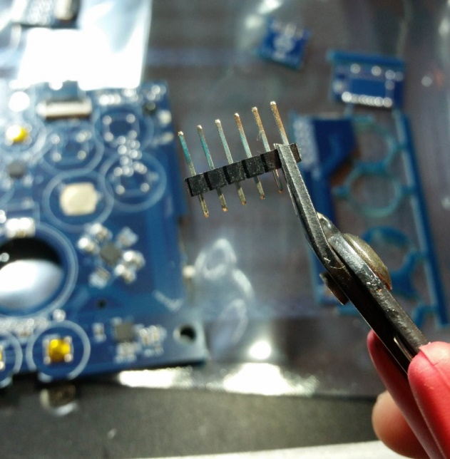

Figure 31 - Cut off a single pin

This pin will be used for holding the power port boards in place when soldering. It will also help with strain relief on the power port boards when inserting and removing the micro USB cable.

The power port is made up of two small boards. There’s the board with the actual micro USB port, and a small riser board of the same shape. These are shown in the AIO board pictures at the beginning of this manual.

Put the pin through the two boards, and through the main board. Pinch the pieces together and hold them in place. Put a blob of solder on the iron, and apply that solder to connect the pin to the board, as shown below. This solder joint can be ugly, we just want it to hold the pin in place, so it holds the boards in place.

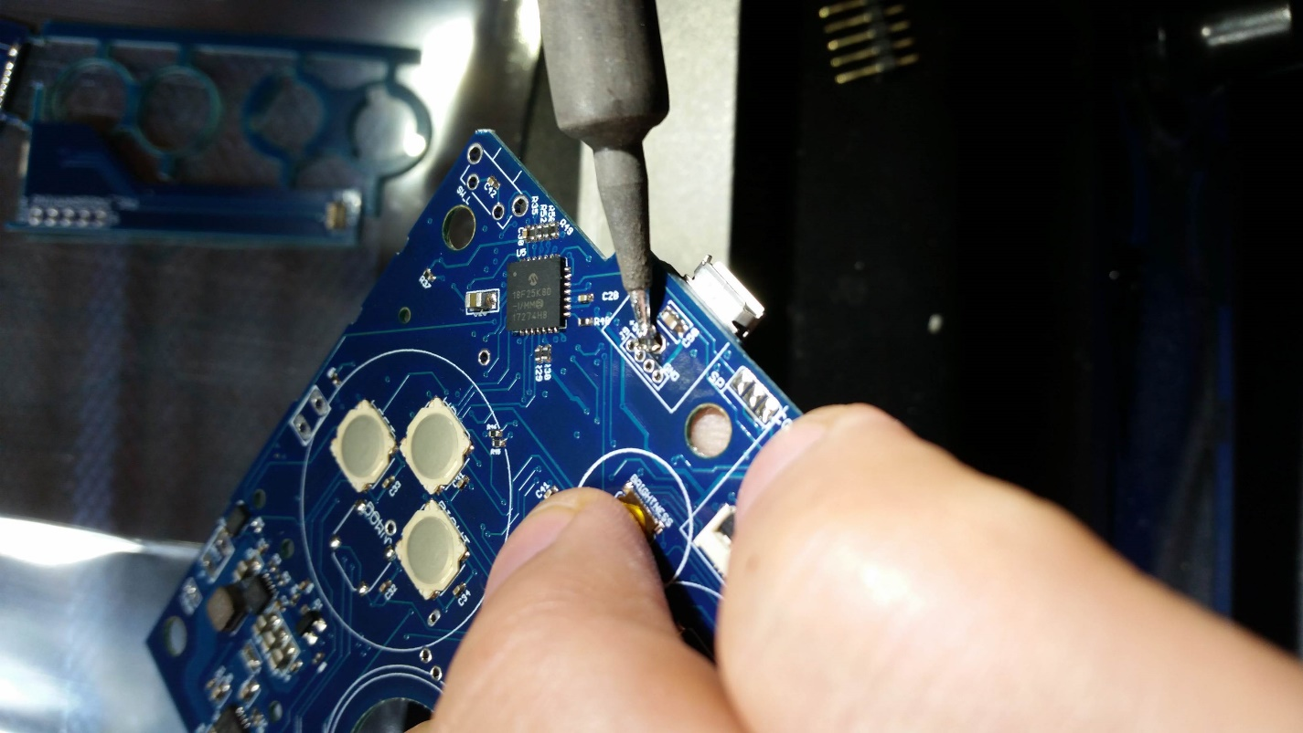

Figure 32 - Solder to hold the micro USB pin in place

The solder on one side, and the plastic piece of the pin on the other side should hold the boards in place. But they are still able to rotate, so that’s where we use the sewing needle. Put the needle through one of the holes to keep the boards from rotating.

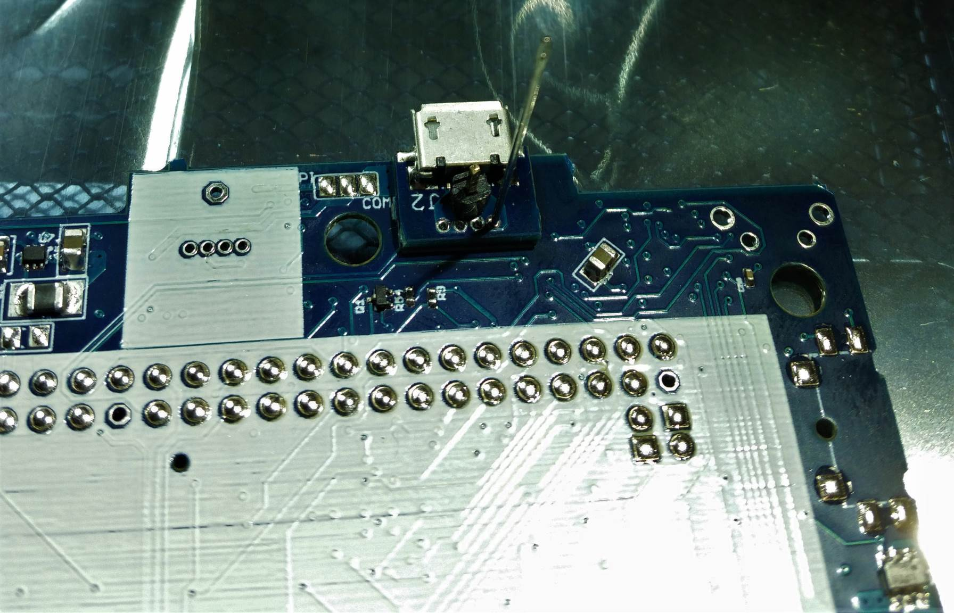

Figure 33 - Sewing needle to stop boards from rotating

**Now apply flux from the pen to the holes**. This will make the soldering easier. Get the iron into the hole to heat everything up, and slowly add solder so it fills all the way through.

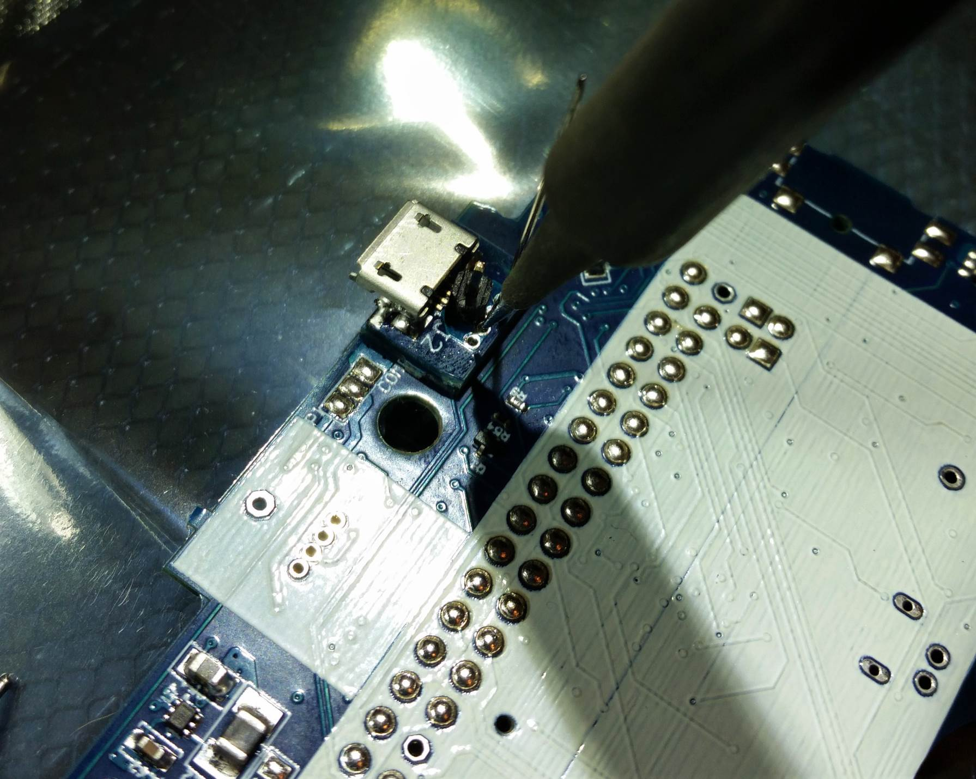

Figure 34 - Soldering iron into holes for USB power

Check the back side of the board to see solder beginning to come through. Then put the iron through the back side of the board to flow the solder from this side.

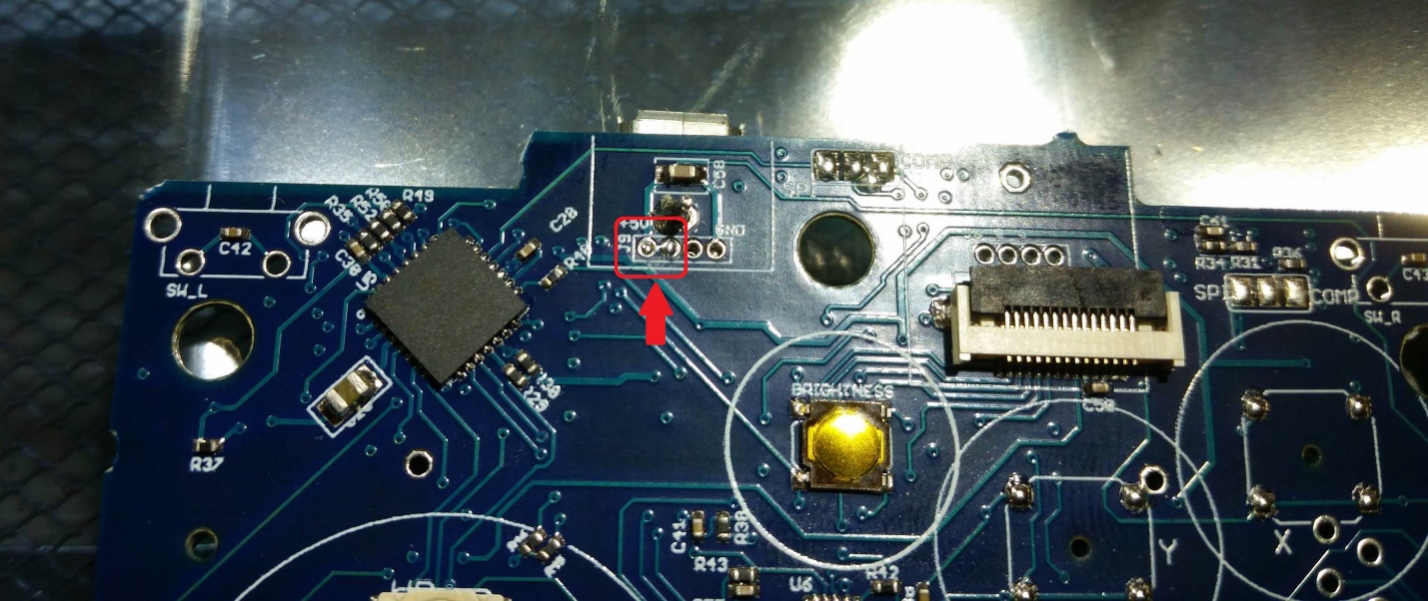

Figure 35 - Solder coming through the holes in the board

Finish soldering the rest of the holes, then securely solder the back side of the pin. Then use the needle nose pliers to slowly pull off the plastic on the pin.

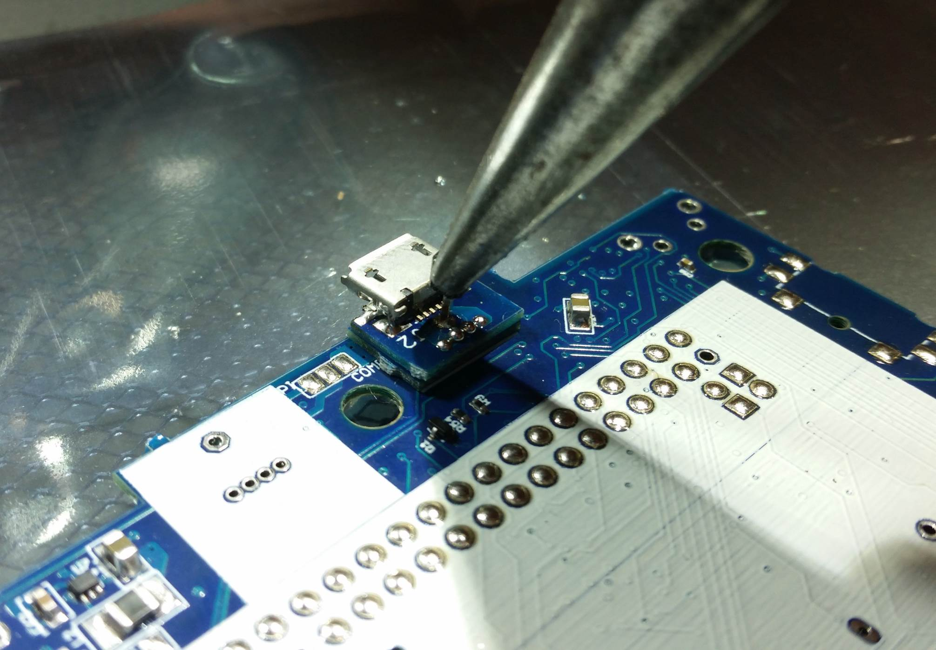

Figure 36 - Remove the plastic piece of the pin

The pieces in the red and yellow boxes are connected together, so it is alright if the solder bridges, as it is in the picture below.

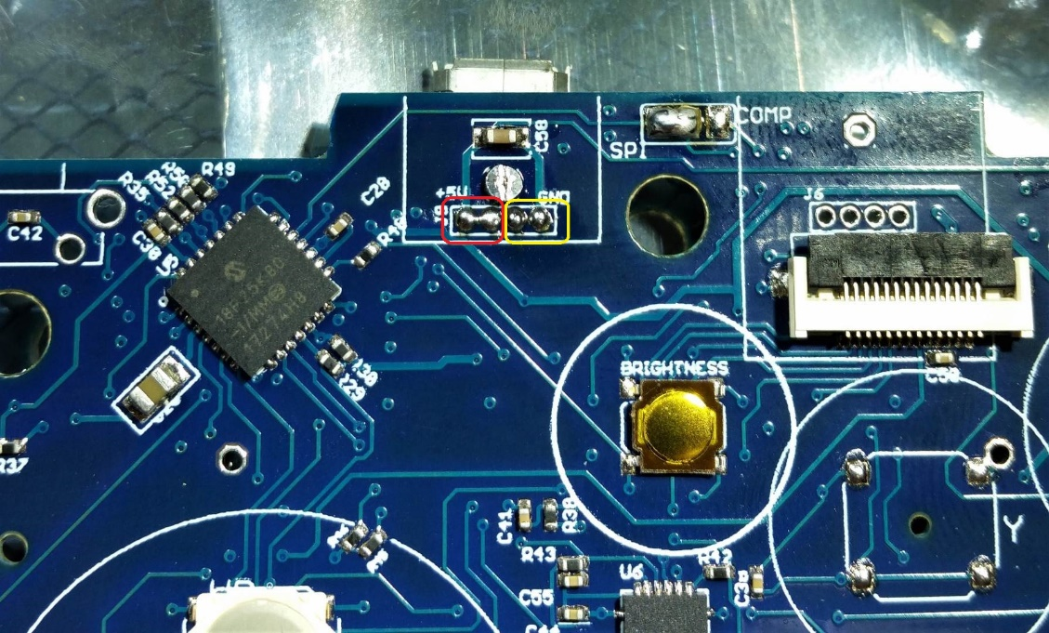

Figure 37 - These are connected together

Finish soldering the pin, and clip the pin close to the board on both sides.

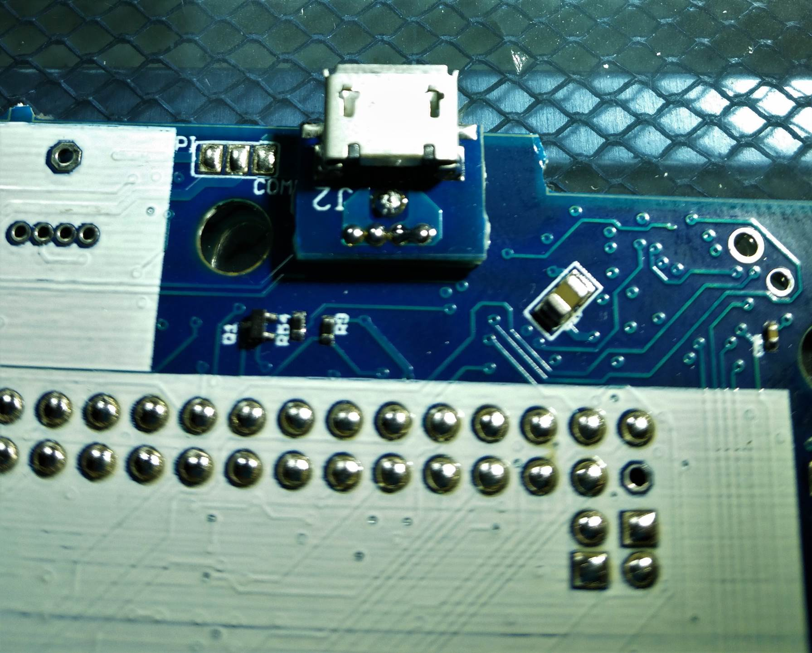

Figure 38 - Finished power port soldering

## Attaching the Raspberry Pi

Now we can finally attach the Raspberry Pi Zero board. This is a bit tedious, but important to do right.

Please refer to some of Kite’s soldering descriptions, they are way better than mine:

https://github.com/kiteretro/Super-AIO/wiki/Pi-Zero-SAIO-v0.6c

First put a little more solder on all the pads, to make little solder balls, like in the picture below. Try to keep their height as even as possible.

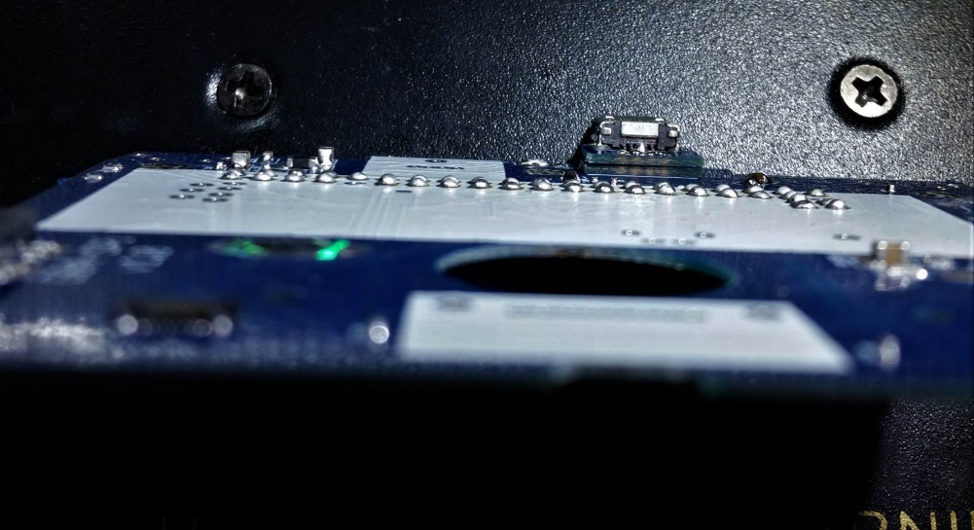

Figure 39 - Solder balls for Pi attach

**Next, brush all the solder balls with the flux pen!** I’m a big fan of flux, it makes soldering much easier. Then there are two through hole positions in the board, where you can insert solder pins. This helps keep the Pi aligned to the rest of the balls, and holds it down while soldering the first few pieces.

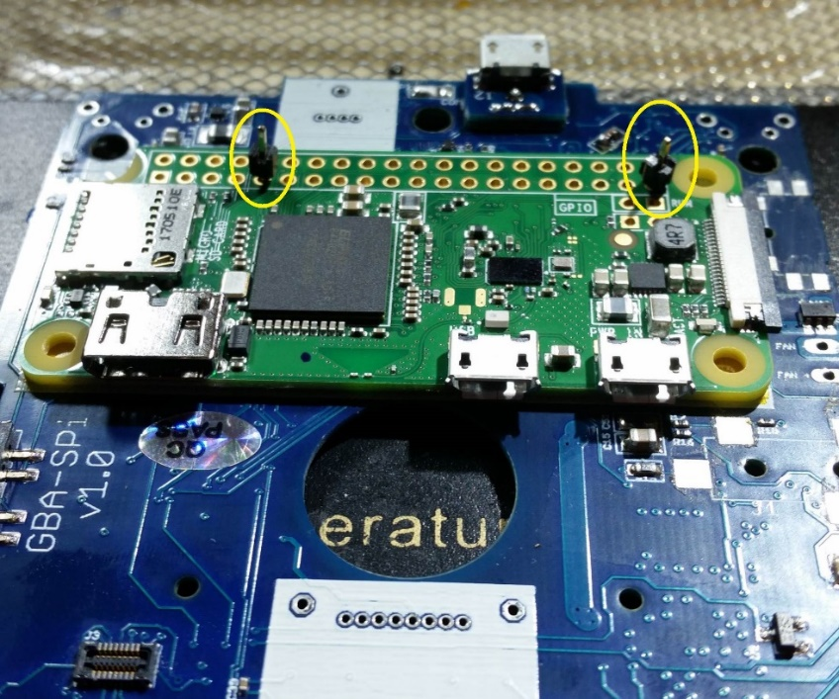

Figure 40 - Pi alignment pins

The pins come through the other side of the board. While holding the Pi and the pin (just hold it by the plastic piece) tight to the board, put a quick solder blob on the other side of the board, to secure the pin in place.

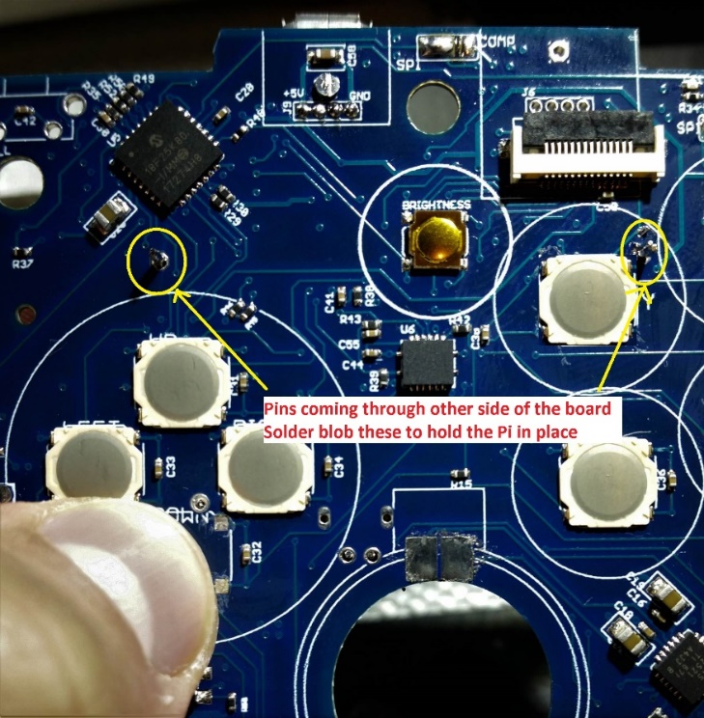

Figure 41 - Solder blobs on back side of Pi alignment pins

**Now add more flux!** Use the flux pen to get flux down into the holes on the Pi.

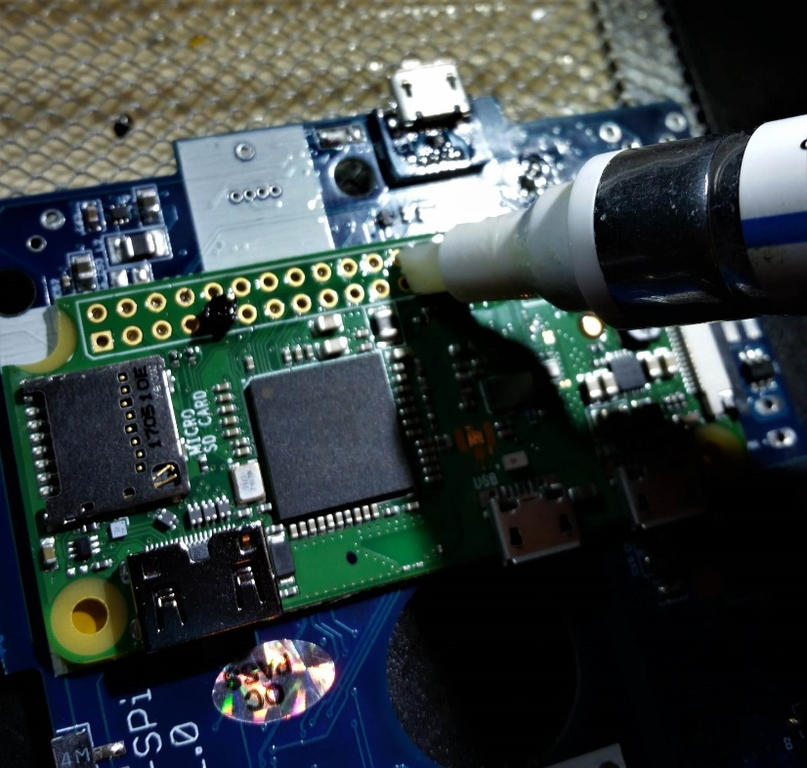

Figure 42 - More flux on Pi pins

Insert the soldering iron into a few holes and just melt the solder ball, drawing the solder up into the hole. Do this just on a few of the pins, just to get the Pi reasonably secured to the board.

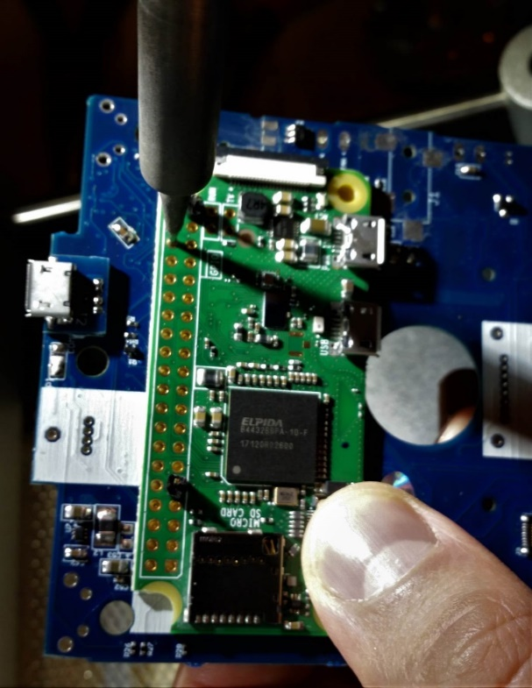

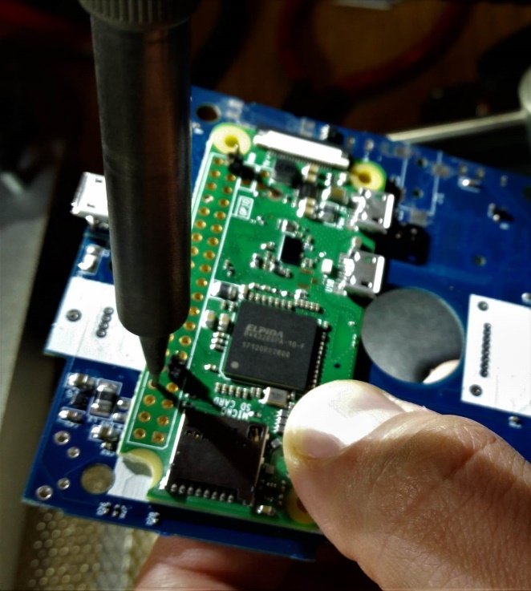

A few of the pins should look like the picture below. This should hold the Pi in place well enough to solder the rest of the pins.

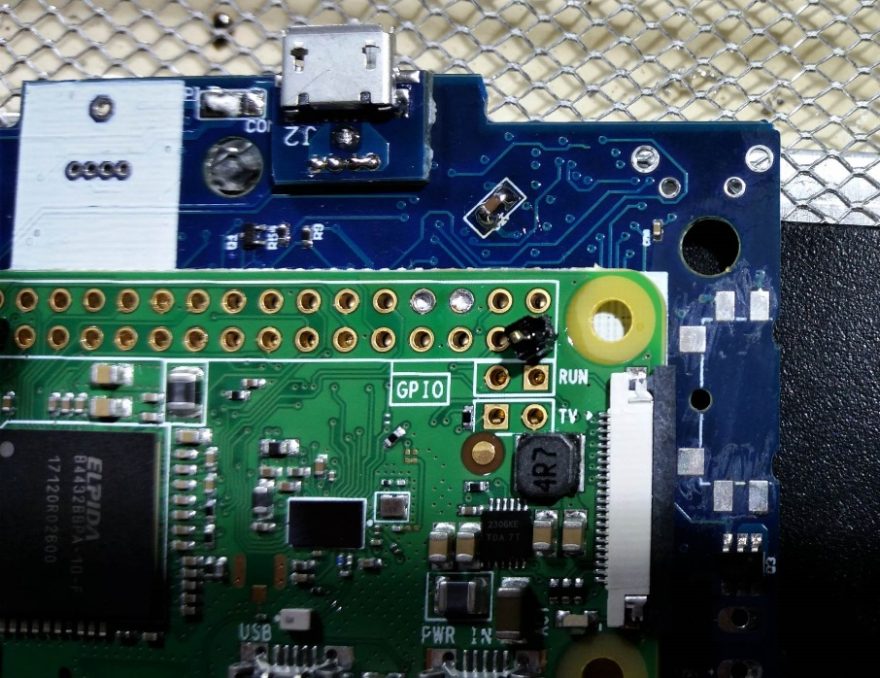

Figure 43 - First pass soldering of a few Pi pins

After the Pi is held in place by the initial soldering, you can start soldering the rest of the pins. The pin should have a small shiny dome of solder when it is properly done.

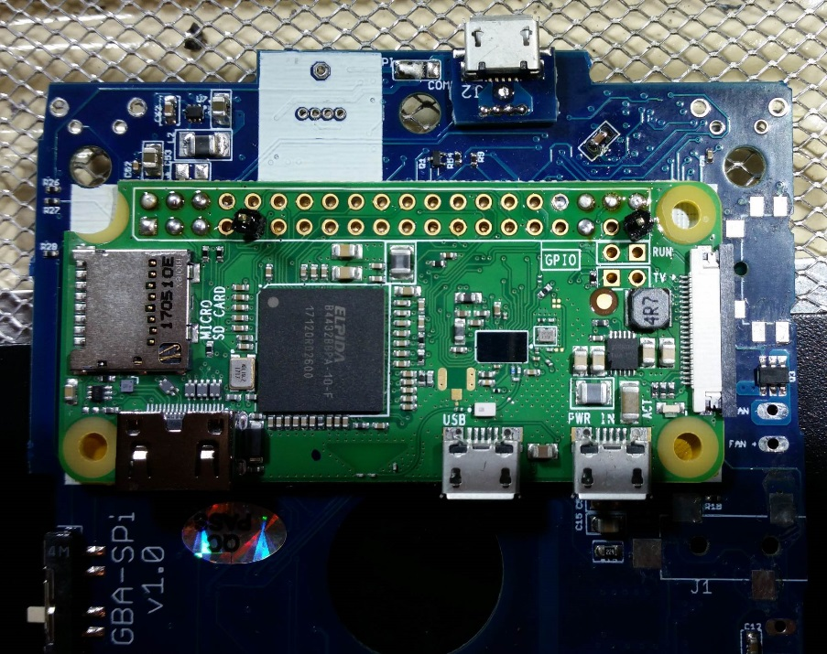

Figure 44 - Starting to solder the rest of the pins

Once more pins have been soldered, you can clip the alignment pins on both sides of the board, and properly solder them into place.

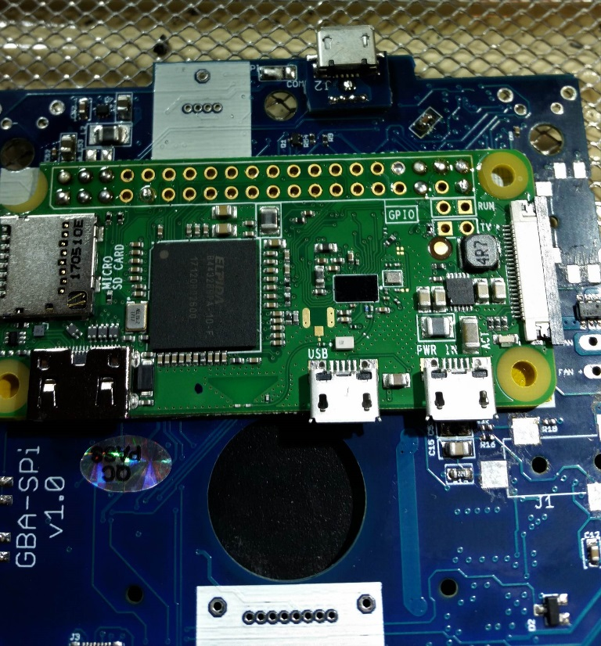

Figure 45 - Clip and solder the alignment pins

Finish soldering the rest of the pins. Nearly every connection is used, so they all need to be properly soldered. Again, the final result should be a rounded, shiny ball on every pin. But also be careful not to add too much solder, since it could short pins underneath the board, and this is very hard to fix!

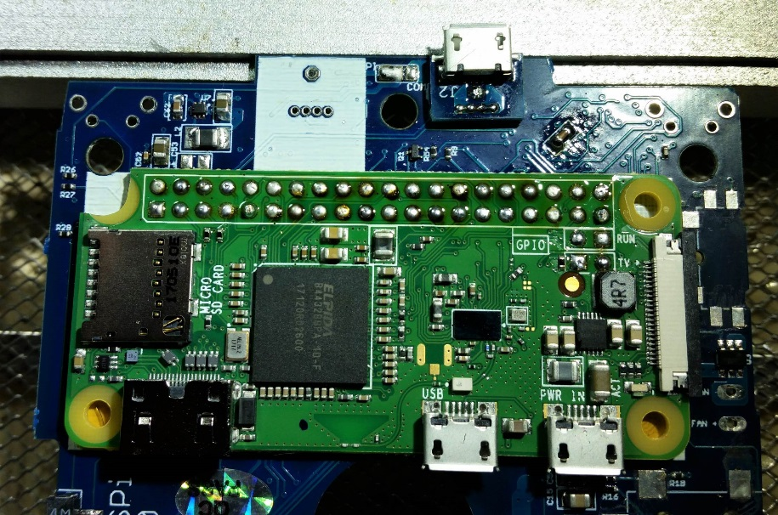

Figure 46 - Finished soldering Pi pins

Now flip the board over, and don’t forget to solder the USB pins. Use the same technique as soldering the Pi pins.

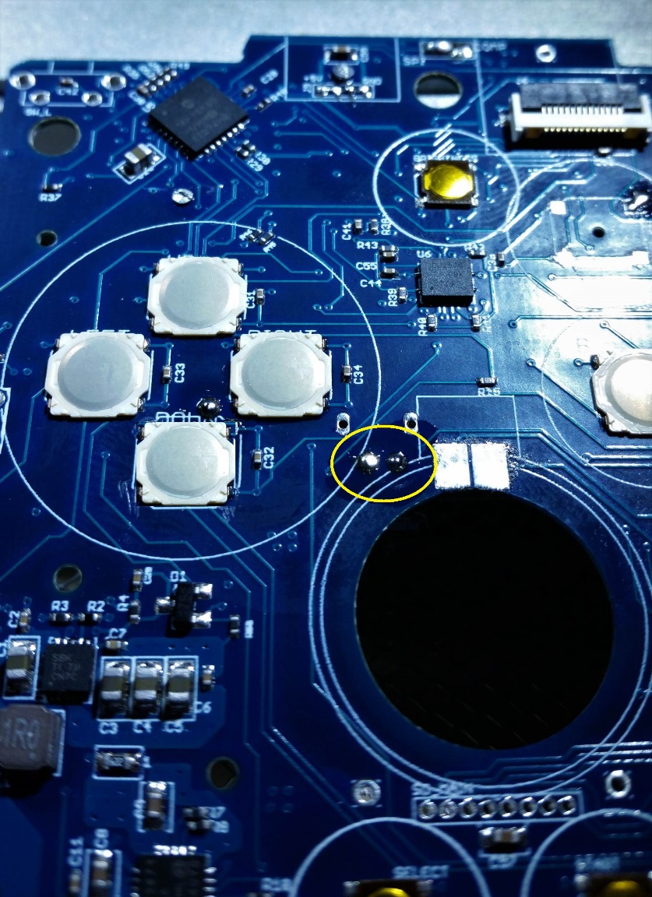

Figure 47 - Solder the USB pins

## Headphone Jack

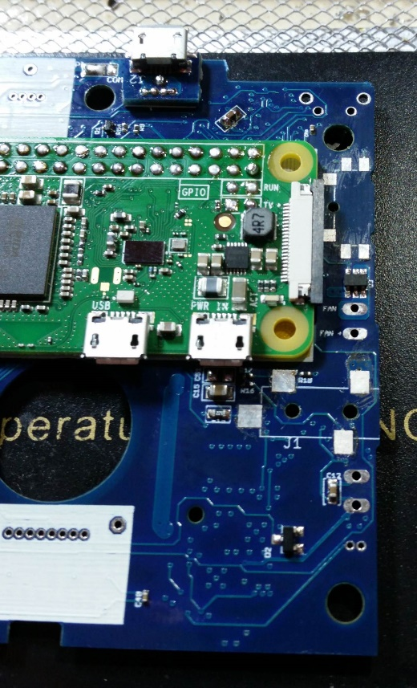

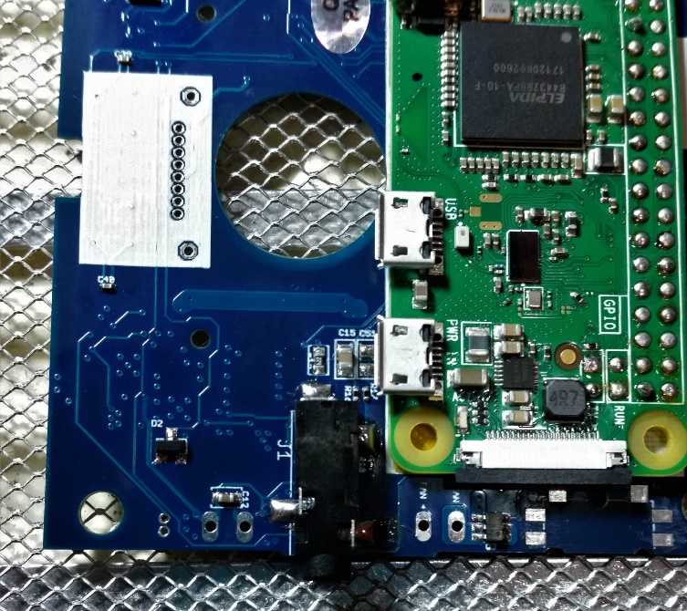

## Volume Slider

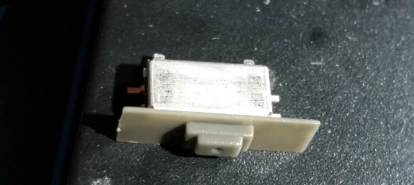

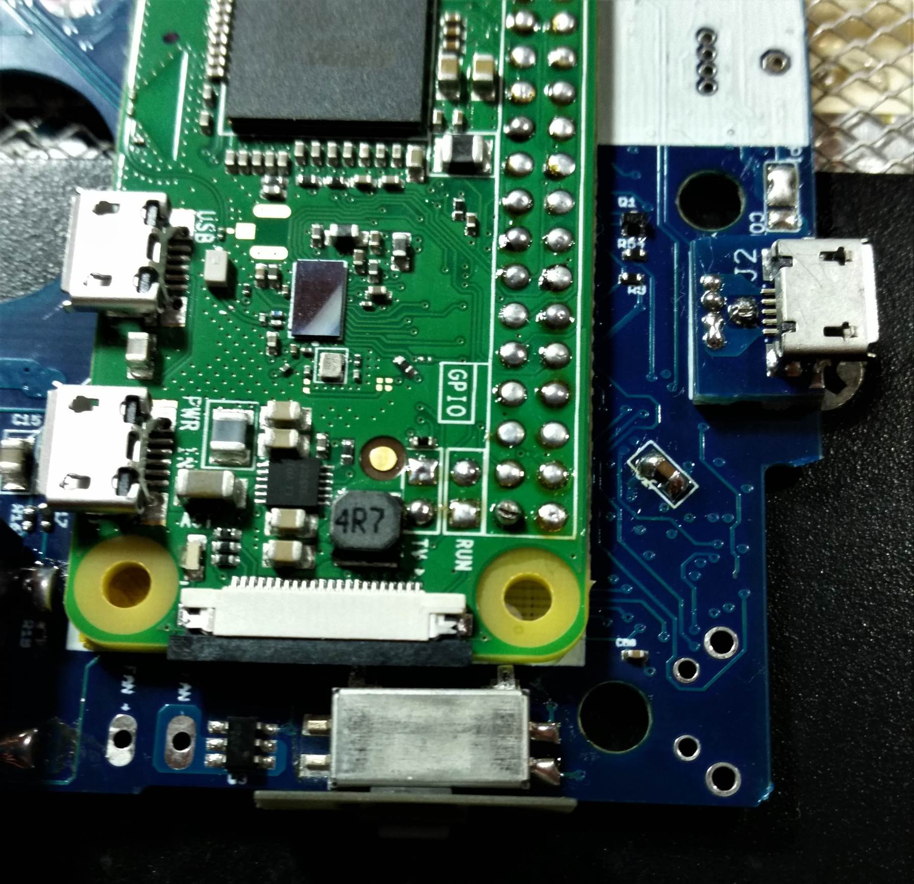

## Screen assembly

